**Unit 5A Study Guide Part 1** Name______________________________________

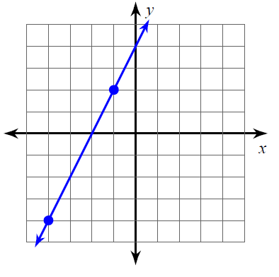1) Find the equation of the line that is:

**Parallel** to the graphed line and passes through the point (2,8).

**Perpendicular** to the graphed line and passes through the point (-10, 6).

1. Find the equation of a line passing through the point (-6, 5) **parallel** to the line  .
2. Find the equation of a line passing through the point (6, 3) **perpendicular** to the line  .
3. Find the **distance** between the points (-18, 12) and (-1, -42).
4. 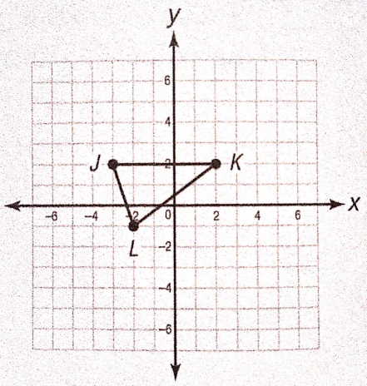Identify the following in order to answer the questions below.
   1. Slope of  _____ Length of ___________
   2. Slope of _____ Length of ___________
   3. Slope of _____ Length of ___________
   4. Is triangle JKL a right triangle? Explain.________________________________________________________________________________________
   5. Is triangle JKL an isosceles triangle?

Explain.________________________________________________________________________________________

1. 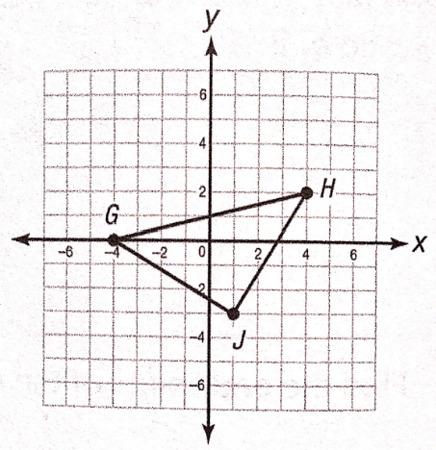Identify the following in order to answer the questions below.
   1. Slope of  _____ Length of ___________
   2. Slope of _____ Length of ___________
   3. Slope of _____ Length of ___________
   4. Is triangle GHJ a right triangle? Explain.________________________________________________________________________________________
   5. Find the area of triangle GHJ.

______________________________________________________________________________________________

1. Given points A(-3, -4) and B(5, 0), find the coordinates of the point P on segment  that **partitions**

in the ratio 2 : 3.

8) Right Triangle **ABC** is shown below. Points **R** and **T** are the midpoints of sides **AB** and **BC,** respectively.

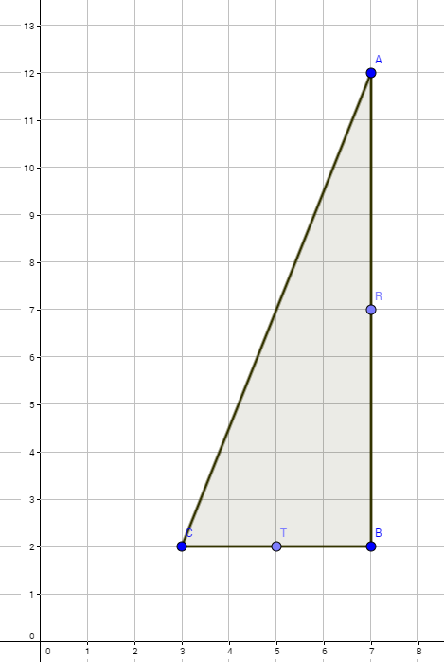

A. Prove that the line that connects midpoints **R** and **T** is parallel to side **AC**. (Show that the slope of line AC is equal to the slope of line RT).

B. Prove that the line that connects midpoints **R** and **T** is half the length of side **AC**. (Use the distance formula to find the length of side AC and RT.)