**Unit 5A Review Part 2 Name_________________________**

1. Is triangle ABC a right triangle? Identify the slopes of all three sides of the triangle to determine if any two sides have opposite reciprocal slopes.

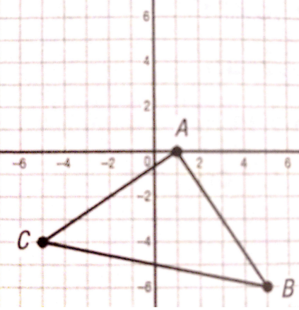

2. Is the triangle equilateral, isosceles, or scalene? Find the distance of each side.



3.  has endpoints *A*(-12, 7) and *B*(3, -14). 4. What is the perimeter of trapezoid DEFG?

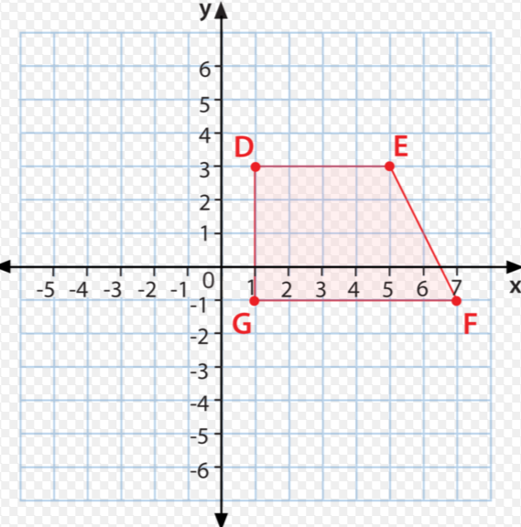What are the coordinates of the midpoint of ?

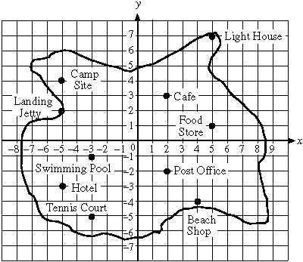

1. What is the point midway between the

Camp Site and the Beach Shop?________

1. Line segment  has been bisected at the point  . If point  , then what are the coordinates of point *Q*? ________
2. Line segment  has endpoints  and . Select 3 points that are on the perpendicular bisector of ?
   1. 
   2. 
   3. 
   4. 
   5. 
   6. 
   7. 

________

1. The local recreation department has created a map of its newest baseball field. The department is planning to install a rectangular fence around the field. The corners of the field are represented on the map by the points A (–5, –10), B (13, –4), C (4, 23), and D (–14, 17).

Each unit on the map represents 10 feet.

How many feet of fencing are needed for the baseball field? __________

1. What is the area of the fenced-in field? ___