## GSE Honors Geometry Name ____________________

**1A-4 Transformations in the Coordinate Plane Translations, Rotations, and Reflections**

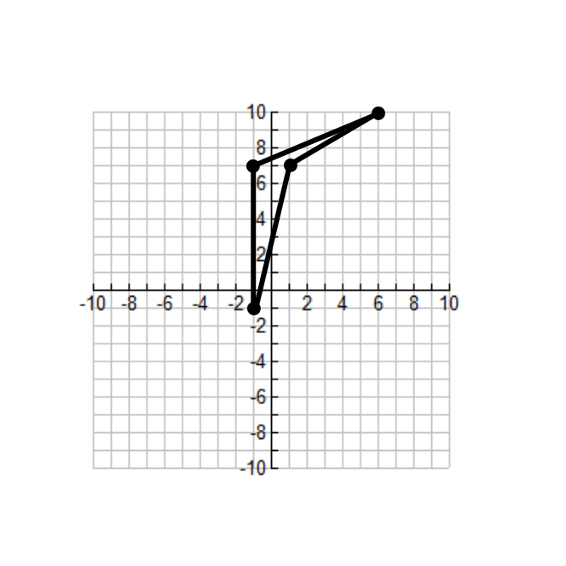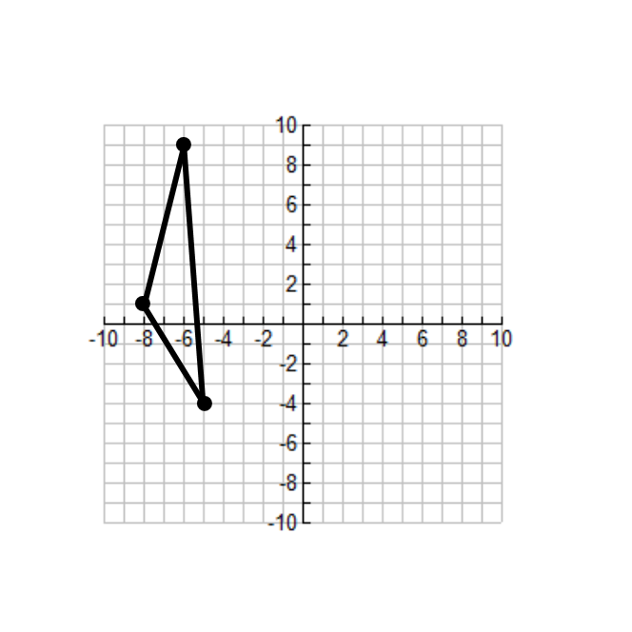Using each pre-image and the given transformation, plot the image on the coordinate plane

1.  2. 

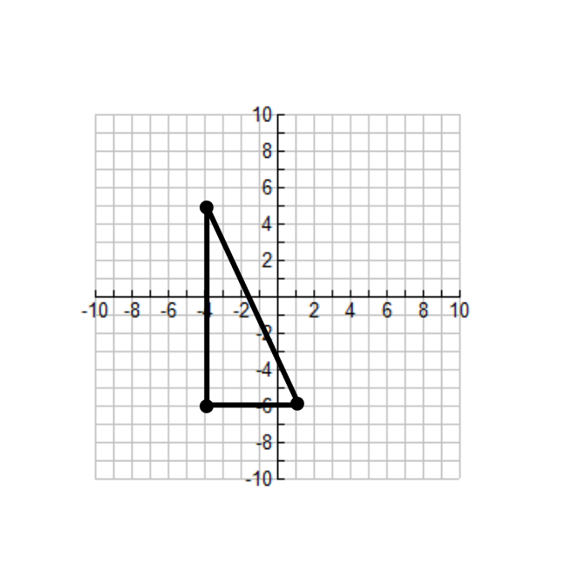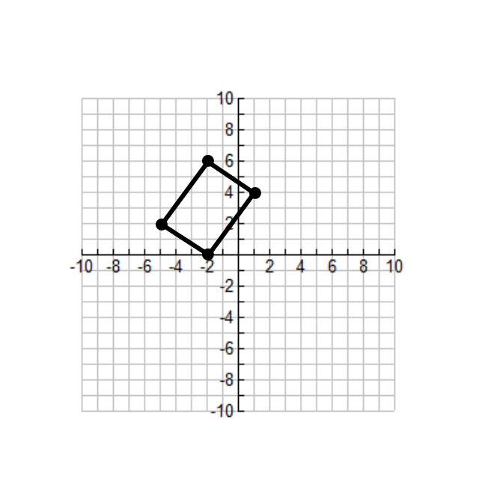

3.  4. 

Given the coordinates of the vertices of the pre-image, use the translation to find the coordinates of each image

5. A(4, 1) B(-7, 10) C (5, -9) 6. A(-1, -1) B(0, 9) C(4, -12) D(-6, 0)

 

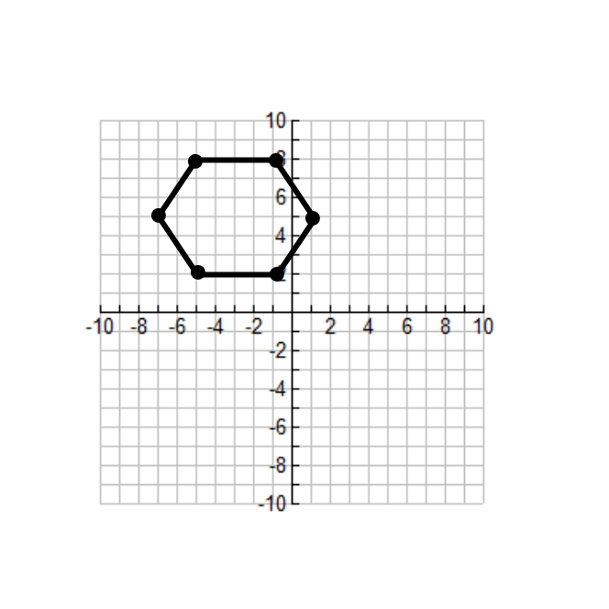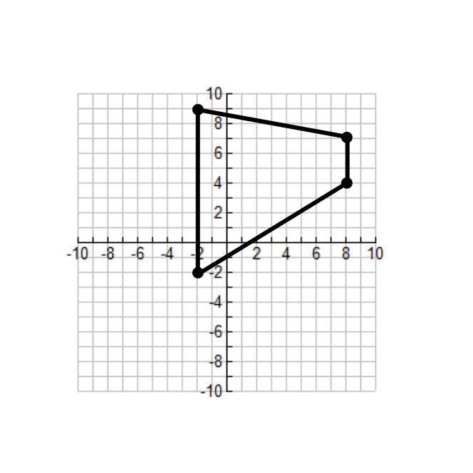Using each pre-image and the given transformation, plot the image on the coordinate plane

7. Reflection across the y-axis 8. Reflection across the x-axis

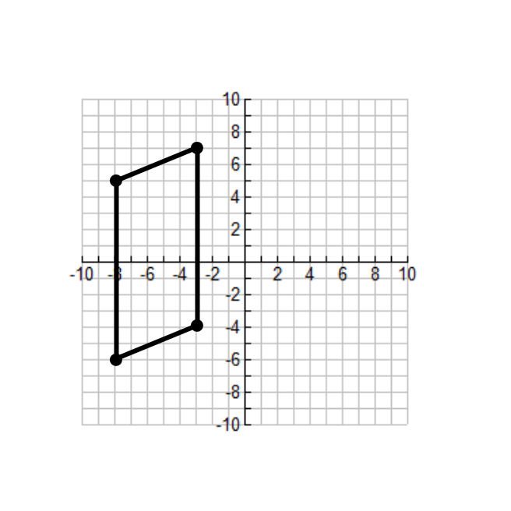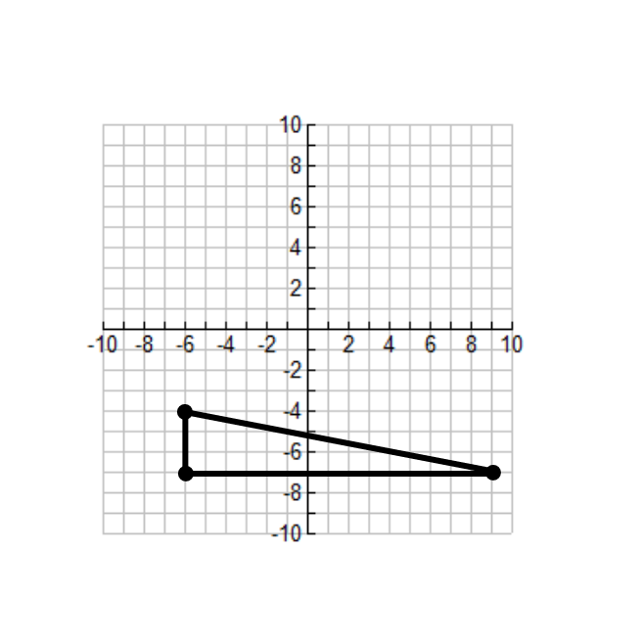

9. Reflection across the line  10. Reflection across the line 

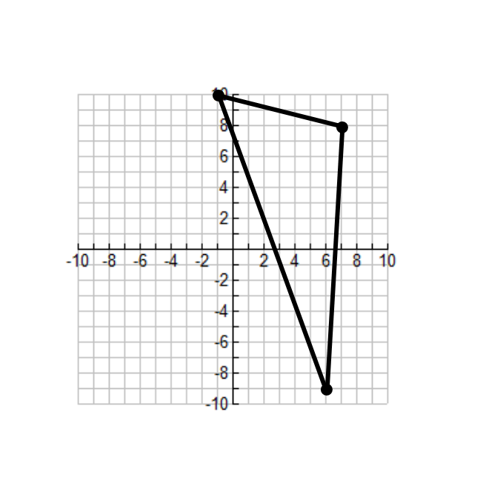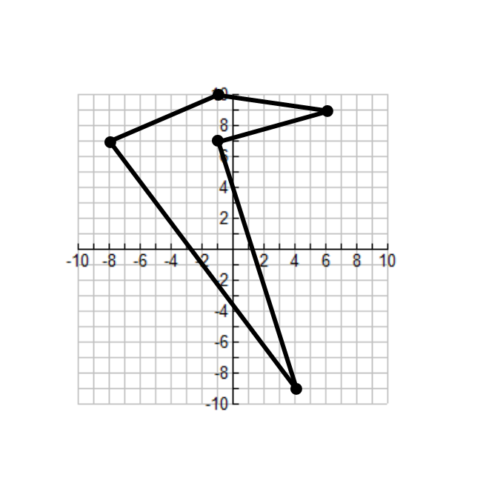

11. Reflection across the line  12. Reflection across the line 

Given the coordinates of the vertices of the pre-image, use the reflection to find the coordinates of each image

13. A(12, -1) B(7, 3) C (-2, -9) 14. A(1, -2) B(-17, 0) C(0, 8)

Reflected across the line  Reflected across the *x*-axis

15. A(-13, 0) B(2, 10) C (-3, -71) 16. A(0, 5) B(18, -13) C(-1, -1)

Reflected across the *y*-axis Reflected across the line 

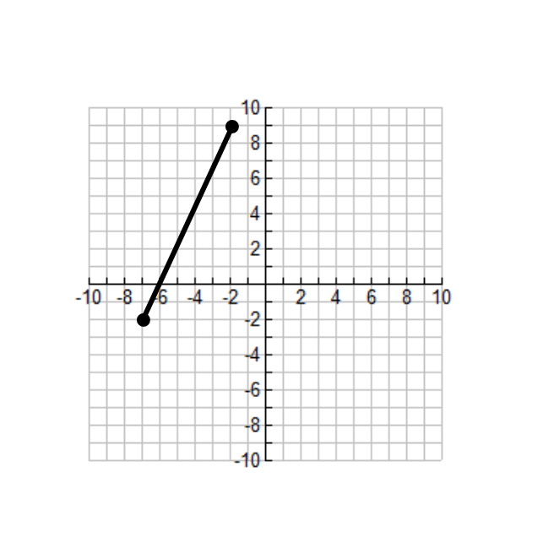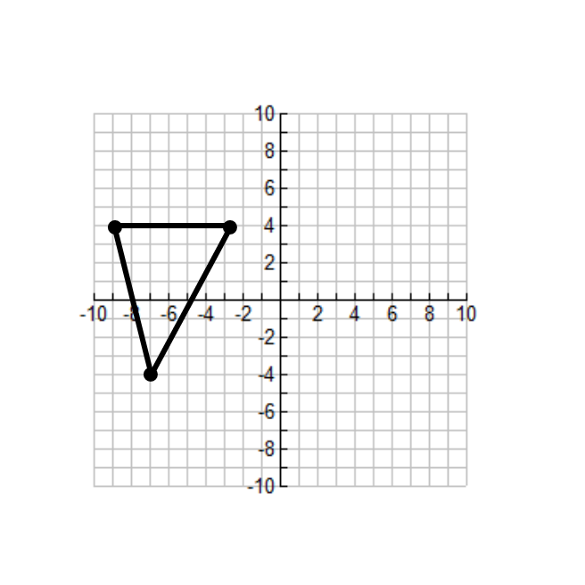Using each pre-image and the given transformation, plot the image on the coordinate plane

17. Rotation 180o about the origin 18. Rotation 90o counterclockwise about the origin

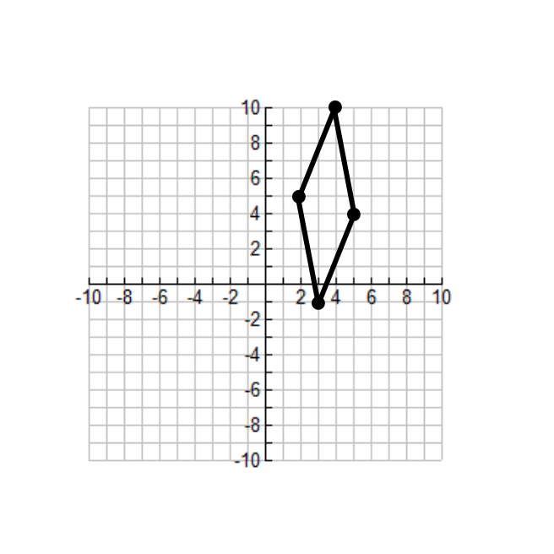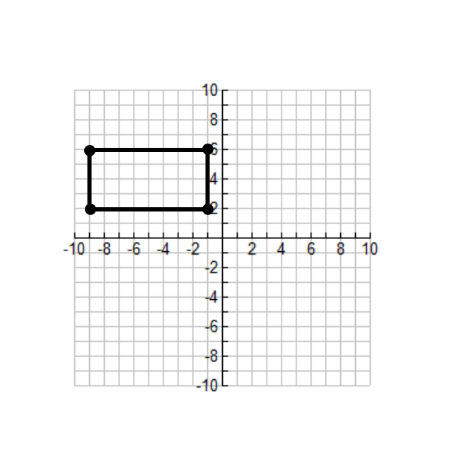

19. Rotation 90o clockwise about the origin 20. Rotation 90o counterclockwise about (2, -3)

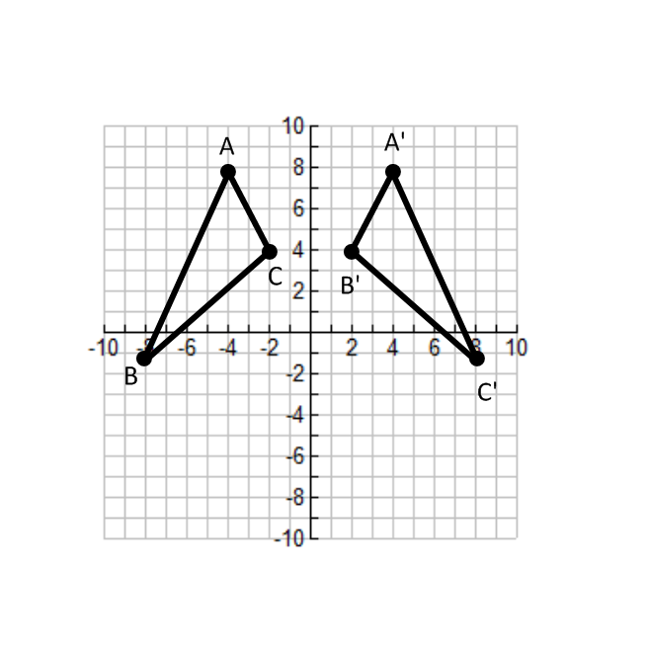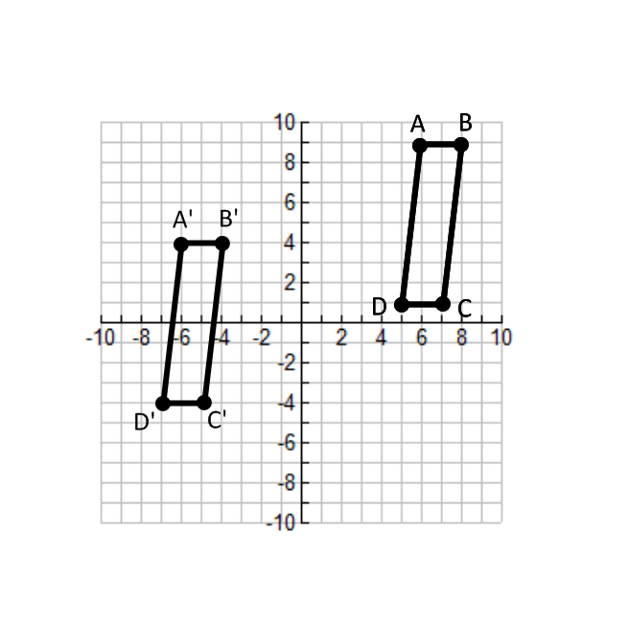Write a rule to describe each transformation

21. 22.

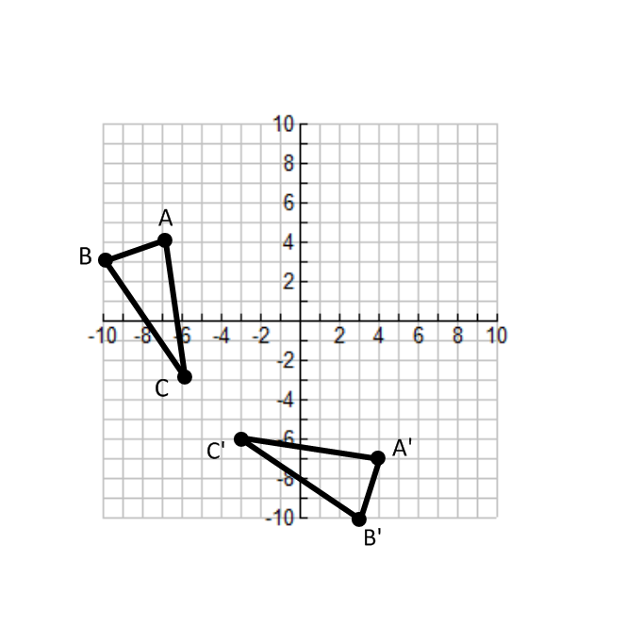

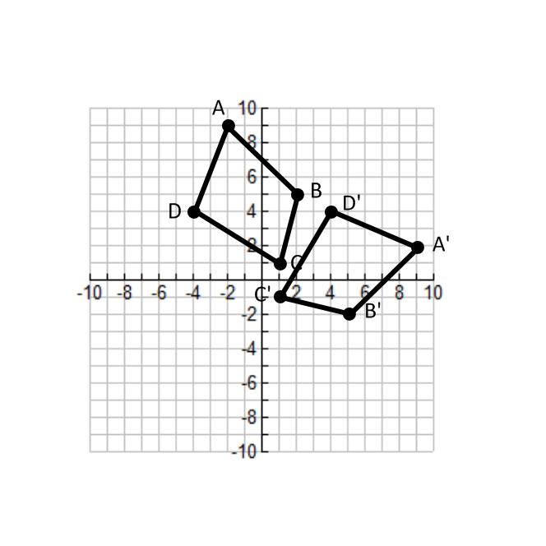

23. 24.