Name________________________________Date________
Given that A and B are complementary angles:
Label each triangle side lengths using the ratios, and A and B if not already labeled
1. sin A = 3/5  B  A  cos B= | 2. cos $θ$ = 5/6  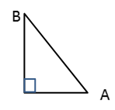  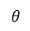  Sin$(90-θ)$= | 3. sin A = 3/5  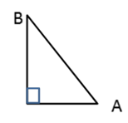  cos B=
4. sin$(90-θ)$ = 3/8  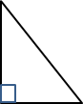  cos$θ$= | 5. sin $θ$ = 20/37  cos $(90-θ$) = | 6. sin B = 25/38, what other trig ratio = 25/38?  A  ________  B
7. If cos A = 17/35, what other trig ratio = 17/35?  ________ | 8. If sin A = 38/91, what other trig ratio = 38/91?  _________ | 9. If cos B= 16/25, what other trig ratio = 16/25?  _______
10. If sin A = 8/17  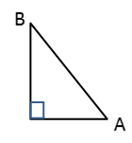  $\overline{AC}=$________  C  cos A =______ | 11. If cos B = 3/5  $\overline{AC}=$________  C  sin B =______ | 12. If tan B = 5/12  ,  $\overline{AB}=$________  C  cos B =______
13. If sin $θ$ = 30/34, what is cos $(90-θ)$?
In your own words, explain why.

Find the missing angle.
14.  $$sin20°=cos⁡________°$$ | 15.  $$sin50°=cos⁡________°$$ | 16.  $cos32°=sin⁡_________°$
17.  $cos51.2°=sin⁡________°$ | 18.  $cos38°45'=sin⁡_________°$ | 19.  $sin 82°5'30"=cos⁡____________°$

Find all trig ratios for each right triangle.
20.  sin A= ______ sin B = _____  cos A = _____ cos B =_____  13  5  12  tan A =______ tan B = _____ | 21.  sin A= ______ sin B = _____  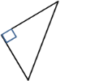  cos A = _____ cos B =_____  A  B  8  6  10  tan A =______ tan B = _____
22.  $\sin{θ}=$______ $\sin{(90-θ)}=$ _____  $\cos{θ}=$ _____ $\cos{(90-θ)}=$_____  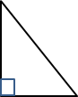  $\tan{θ}=$ ______ $\tan{(90-θ)}=$ _____  θ  5  3  4 | 23.  sin A= $\frac{21}{35}$ sin B = _____  cos A = _____ cos B =_____  tan A = _____ tan B = $\frac{28}{21}$  A  B

Answers rounded to the nearest thousandth.
24. A and B are complimentary angles. If Cos(A)=10/27, what is Tan(B)?

25. A and B are complimentary angles. If Sin(A)=7/11, what is Cos(A)?

