2B-2

Similarity and Transformations

Apply the dilation *D* to the polygon with the given vertices. Describe the dilation as an enlargement or a reduction.

|  |  |
| --- | --- |
| 1. D: (x, y) → (2x, 2y)  A(1, 2), B(3, 3), C(4, 1)  BUGE11SE_C07_L02A_T01  A’ \_\_\_\_\_\_\_\_\_  B’ \_\_\_\_\_\_\_\_\_  C’ \_\_\_\_\_\_\_\_\_  \_\_\_\_\_\_\_\_\_\_\_\_\_\_\_\_\_\_\_\_\_\_\_\_\_\_\_\_\_\_\_\_\_\_\_\_\_ | 2. D: (x, y) → (x, y)  P(6, 8), Q(0, 6), R( –4, 2)  BUGE11SE_C07_L02A_T03  P’ \_\_\_\_\_\_\_\_\_  Q’ \_\_\_\_\_\_\_\_\_  R’ \_\_\_\_\_\_\_\_\_  \_\_\_\_\_\_\_\_\_\_\_\_\_\_\_\_\_\_\_\_\_\_\_\_\_\_\_\_\_\_\_\_\_\_\_\_\_ |
| 3. D: (x, y) → (1.5x, 1.5y)  G(4, 1), H(2, 1), J(2, 6), K(4, 6)  BUGE11SE_C07_L02A_T05  G’ \_\_\_\_\_\_\_\_\_  H’ \_\_\_\_\_\_\_\_\_  J’ \_\_\_\_\_\_\_\_\_  K’ \_\_\_\_\_\_\_\_\_  \_\_\_\_\_\_\_\_\_\_\_\_\_\_\_\_\_\_\_\_\_\_\_\_\_\_\_\_\_\_\_\_\_\_\_\_\_ | 4. D: (x, y) → (0.75x, 0.75y)  E(4, 6), F(2, 2), G(4, 2), H (4, 4)  BUGE11SE_C07_L02A_T07  E’ \_\_\_\_\_\_\_\_\_  F’ \_\_\_\_\_\_\_\_\_  G’ \_\_\_\_\_\_\_\_\_  H’ \_\_\_\_\_\_\_\_\_  \_\_\_\_\_\_\_\_\_\_\_\_\_\_\_\_\_\_\_\_\_\_\_\_\_\_\_\_\_\_\_\_\_\_\_\_\_ |

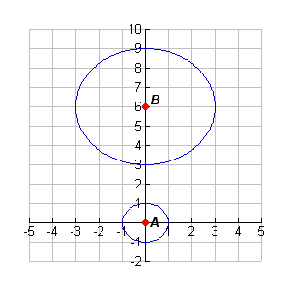

SIMILARITY OF DIFFERENT SHAPES:

Squares? YES or NO Rectangles? YES or NO

Equilateral Triangle? YES or NO Isosceles Triangle? YES or NO

Circles? YES or NO

**Standard MCC9-12.G.SRT.1**:

A dilation takes a line not passing through the center of the dilation to a parallel line, and leaves a line passing through the center unchanged.

Highlight and  . Are they parallel? Highlight  and  . Are they parallel?

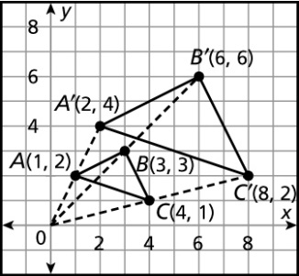 

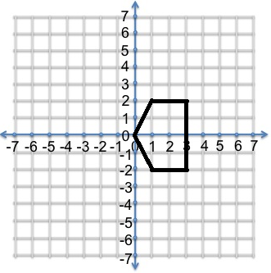

What if the center of the dilation passes through one of the sides of the triangle? Draw a dilation with a factor of 2 to see what happens. Center of Dilation is (0,0). Are ALL corresponding sides parallel? Are some sides on the same line?

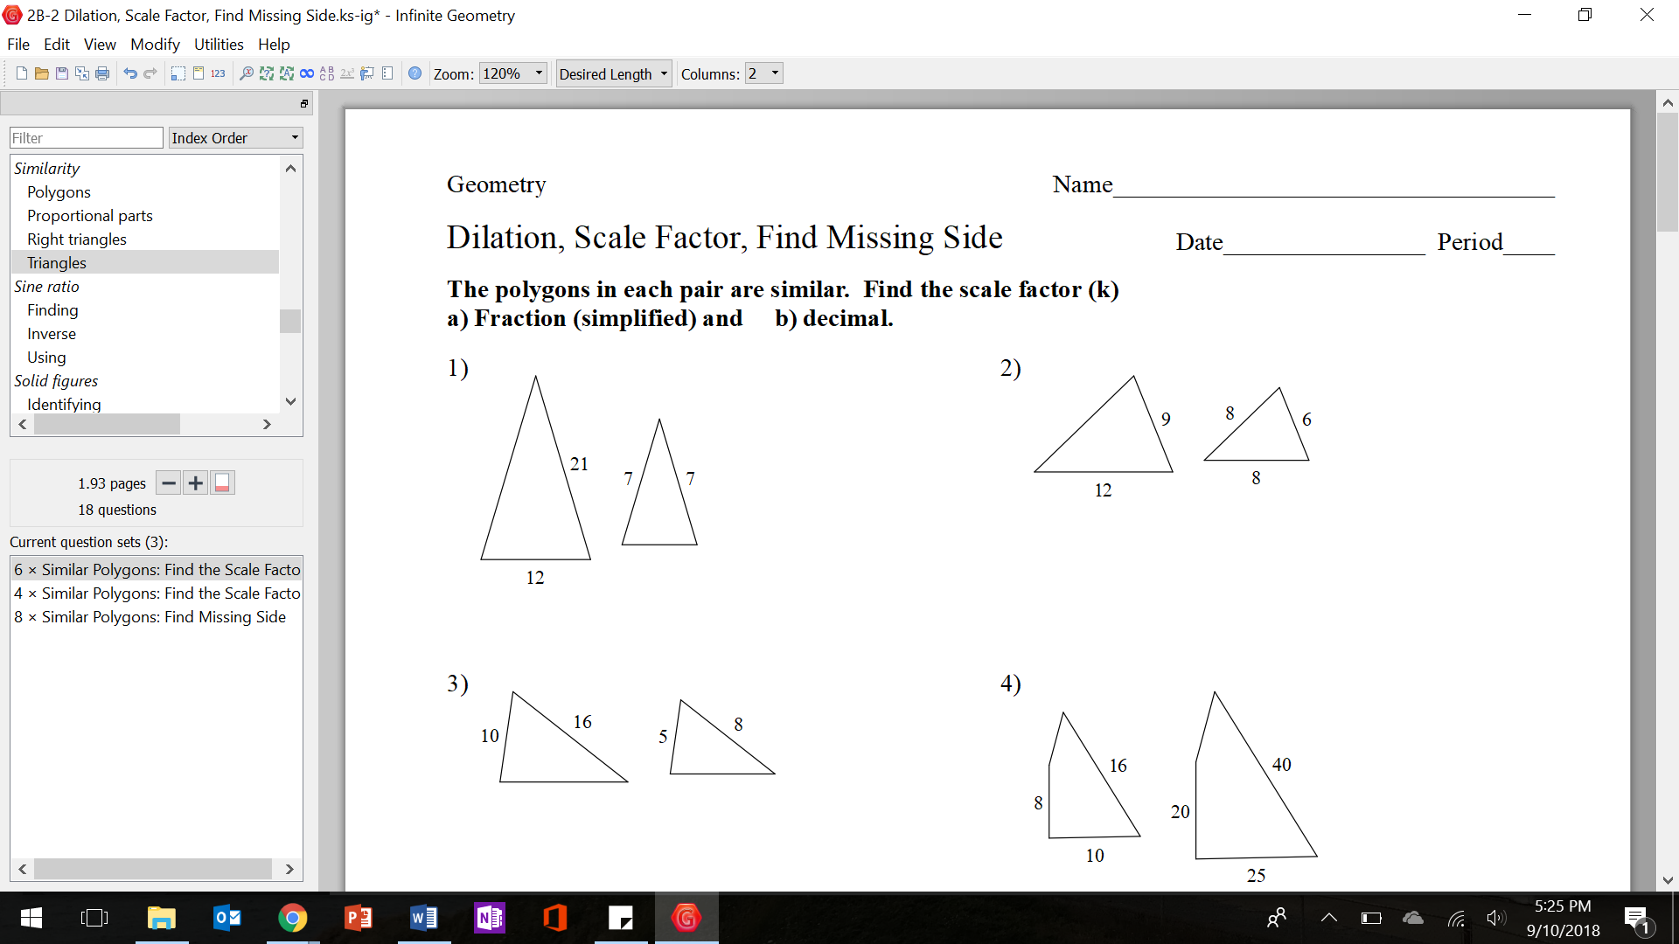

Delta Math Assignment: Dilation/Scale Factor