Name__________________________________

3-1 Circles Theorems

Per.____________Date__________

Find the measure of each angle or arc.

|  |  |  |
| --- | --- | --- |
| 1.  ________  ______  Explain: | 2.  ________  ______ | 3.  ________  ______ |
| 4.  ________  ______ | 5.  ________  ______ | 6.  ________  ______ |
| 7.  _______  ______ | 8.  ________  ______ | 9.  ________  ______ |
| 10.    _____ | 11.    ______  _____ | 12.  _____    _______  _______ |
| 13.    ______  ______ | 14.    ______ | 15.    ______ |
| 16.    __________    __________ | 17.    ______  ______ | 18.  ____  _____ |
| 19.    _____ | 20.    _____ | 21.    _____ |

Constructed Response:

  ______________

 _____________

Describe in your own words, WHY opposite angles are supplementary.

_____________________________________________________________________

_____________________________________________________________________

_____________________________________________________________________

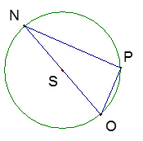

 ________ Explain why.___________

_______________________________________

_______________________________________