**Unit 3 Reference Sheet Name:**

**Circle:** The set of points in a plane that are fixed distance from a given point called the center of the circle.

**Chord:** A segment whose endpoints both lie on the same circle.

**Radius:** A segment whose endpoints are the center of a circle and a point on the circle.

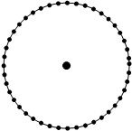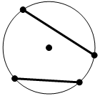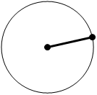



*chord*

**Diameter:** A segment that has endpoints on a circle and that passes through the center of the circle.

**Secant:** A line that intersects a circle at two points.

**Tangent:** A line that is in the same plane as a circle and intersects the circle at exactly one point. The radius is perpendicular to the tangent at the point of tangency.

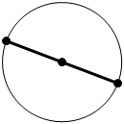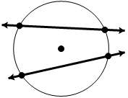

**1.**





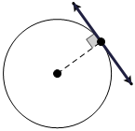



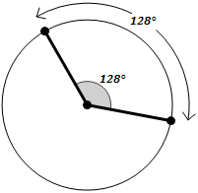.**Central Angle:** An angle whose vertex is the center of a circle.

**Arc:** Part of the circumference of a circle. Measured in degrees. The arc measure = central angle.

**Minor Arc** **Semicircle** **Major Arc**

less than $180°$ = $180°$ greater than $180°$



**1.**

**Inscribed Angle:** An angle whose vertex is on a circle and whose sides contain chords of the circle. The angle measure of the inscribed angle is ½ of the intercepted arc

**Arc Addition Postulate:** The measure of the arc formed by two adjacent arcs is the sum of the measures of the two arcs.

**Theorem:** If an Inscribe angleand a central angle intercept the same arc, then the Inscribed Angle is ½ measure of the Central Angle.



**1.**

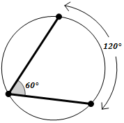

**Inscribed Quadrilateral Theorem:**

IF a quadrilateral is inscribed in a circle,

THEN its opposite angles are congruent.

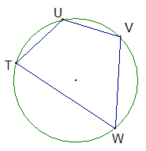  __________

 __________

**Inscribed Right Triangle**

IF an angle is inscribed in a semicircle (or endpoints are on diameter),

THEN the angle is a right angle.

 

 ______

 _____

**Angle formed Two Tangents**

IF a circle has two tangents from the same external point,

THEN the angle formed and the central angle are supplementary. (180*)

