3-5 Area of Circles and Sectors Name________________________________

1. **Find the following sector areas (shaded regions) using fractional parts.**

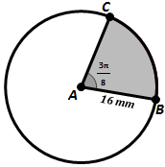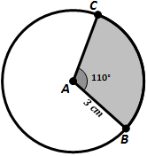

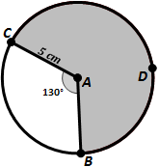

Sector

Area

:

Sector

Area

:

Sector

Area

:

1. **Find the area of each of the shaded regions.**

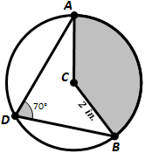

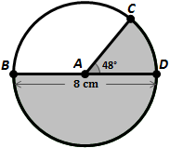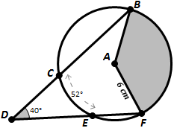

Area:

Area:

*x* =

1. **Solve the following problems.**

**Find the central angle of a sector that has an area of 71 cm2 and a radius of 7 cm.**

**Find the radius of a sector that has an area of 92 cm2 and a central angle of 130˚.**

**Find the area of the shaded region, given that AC is tangent to the circle at point B and $m∡ABE=70°$**

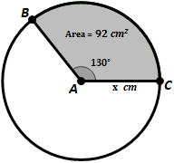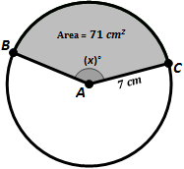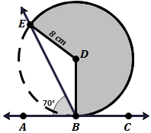

Sector

Area

:

Sector

Area

:

Sector

Area

:

1. **Find the area of each Segment (shaded regions).**

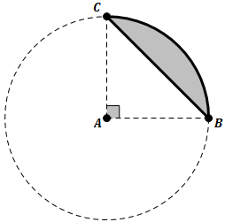

cm



8 m

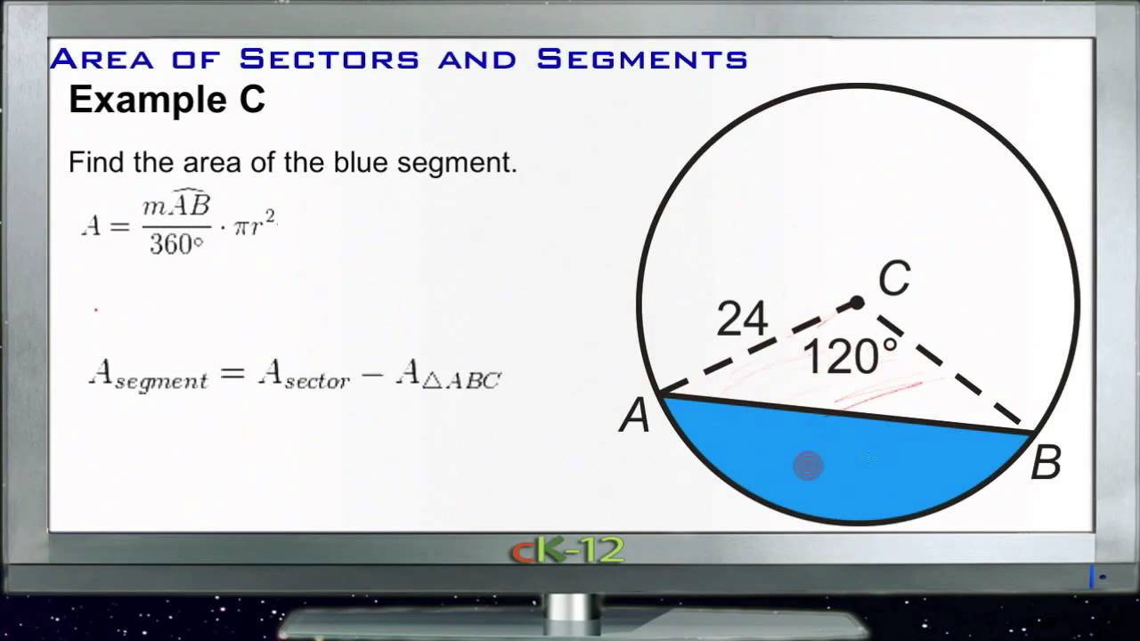

=

Area:

Area:

*Area:*