Name________________________________Date________
Given that A and B are complementary angles:
Label each triangle side lengths using the ratios, and A and B if not already labeled
1. sin A = 3/5  B  A  cos B= | 2. cos A = 5/6  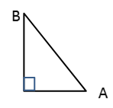  sin B= | 3. If cos A = 17/35, what other trig ratio = 17/35?  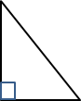  ________  A  B
4. If sin R = 38/91, what other trig ratio = 38/91?  R  T  _________ | 5. If sin A = 30/34, what is cos B? In your own words, explain why.
6. If sin A = 8/17, what other trig ratio = 8/17?  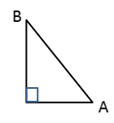  ________  C  $\overline{AC}=$________  cos A =______ | 7. If cos B = 3/5, what other trig ratio = 3/5?  ________  $\overline{AC}=$________  C  sin B =______ | 8. If sin B = 5/13, what other trig ratio = 5/13?  ________  C  $\overline{BC}=$________  cos A =______
Find the missing angle.
9.  $$sin20°=cos⁡________°$$ | 10.  $$sin50°=cos⁡________°$$ | 11.  $cos32°=sin⁡_________°$
12.  $sin 47.2°=cos⁡________°$ | 13.  $cos12.6°=sin⁡_________°$ | 14.  $sin47°=cos⁡_________°$
Find all trig ratios for each right triangle.
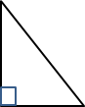  15.  β  θ  5  3  4  $\sin{θ}=$______ $\sin{β}=$ _____  $\cos{θ}=$ _____ $\cos{β}=$_____  $\tan{θ}=$ ______ $\tan{β}=$ _____ | 16.  sin A= $\frac{21}{35}$ sin B = _____  A  B  cos A = _____ cos B =_____  tan A = _____ tan B = $\frac{28}{21}$

