3-6 Circles & Volume
Circumference, Perimeter, Arc Length Name:

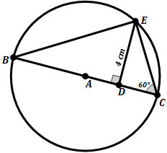
- Find the Circumference of the following circles (assuming point A is the center):
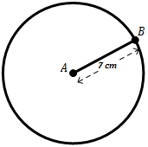
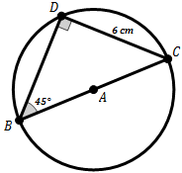
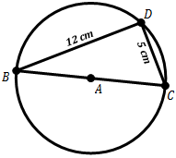
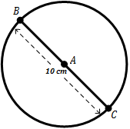
- C. E.

2c. C =
2a. C =

- D.

2e. C =
2d. C =
2b. C =

3. Find the Radius of each circle given the following information:
19.60 cm
- B.
44 cm

3b. r =
3a. r =

4. Find the Arc Length of arc $\hat{BC}$. (Assuming point A is the center)
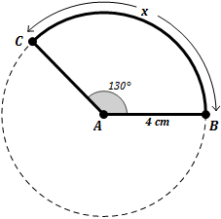
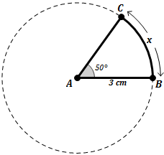
- B.

4b.
4a.

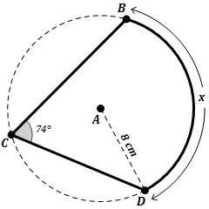
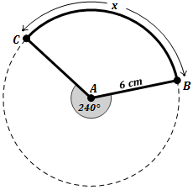
C. D.

4d.
4c.

5. Find the Arc Length of arc $\hat{BC}$. (Assuming point A is the center)
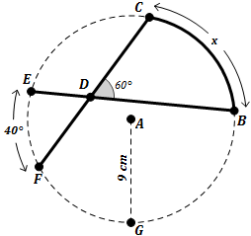
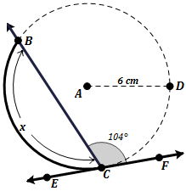
- B.

(Assume EF is tangent to the circle.)

5b.
5a.

- Find the most appropriate value for x in each diagram.
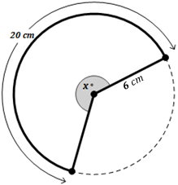
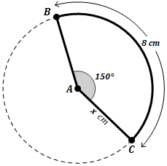
- B.

6a.
6b.

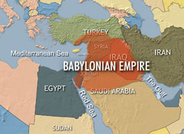
The Babylonian Degree method of measuring angles. Around 1500 B.C. the Babylonians are credited with first dividing the circle up in to 360̊. They used a base 60 (sexagesimal) system to count (i.e. they had 60 symbols to represent their numbers where as we only have 10 (a centesimal system of 0 through 9)). So, the number 360 was convenient as a multiple of 60. Additionally, according to Otto Neugebauer, an expert on ancient mathematics, there is evidence to support that the division of the circle in to 360 parts may have originated from astronomical events such as the division of the days of a year. So, that the earth moved approximately a degree a day around the sun. However, this would cause problems as years passed to keep the seasons accurately aligned in the calendar as there are 365.242 actual days in a year. Some ancient Persian calendars did actually use 360 days in their year further supporting this idea.
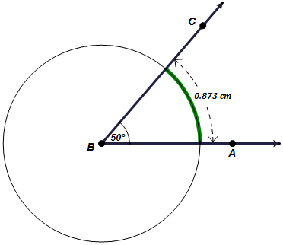
The transition to Radian measure of angle: Around 1700 in the United Kingdom, mathematician Roger Cotes saw some advantages in some situations to measuring angles using a radian system. A radian system simply put, drops a unit circle (a circle with a radius of 1) on to an angle such that the center is at the vertex and the length of the intercepted arc is the radian measure. So, a full circle of 360̊ is equivallent to 2π∙(1) radians. In the example at the right, an angle of 50̊ is shown. Then, a circle that has a radius of 1 cm is drawn with its center at the vertex.
1 cm

Finally, the intercepted arc length is determined to be approximately 0.873 or more precisely $\frac{5π}{18}$ radians.
Similarly, it can be demonstrated the basically that 180˚ is equivalent to π radians.

6. Using the ratio of 180˚: π convert the following degree measures to radians.

a. 30˚ b. 80˚ c. 225˚ d. 360˚

7. Using the ratio of 180˚: π convert the following radian measures to degrees.

a.$\frac{π}{4}$ rads b.$\frac{3π}{10}$ rads c. $\frac{5π}{8}$ rads d.$0.763$ rads

8. Find the Arc Length of $\hat{BC}$ using similar circles or a fraction of the circumference.
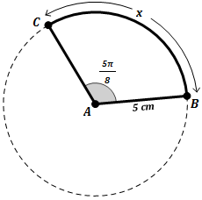
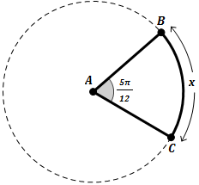
- B.

8b.
8a.

- Solve the following.
Determine the perimeter of the rhombus shown.
Find an expression that would represent the perimeter of the triangle.
Given the perimeter of the rectangle shown below is 32 cm² and the length of one side is 6 cm, determine the area of the rectangle.
- B. C.
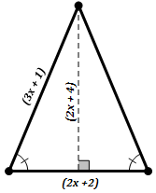
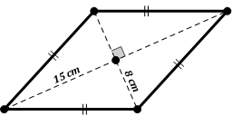

9c.
9b.
9a.

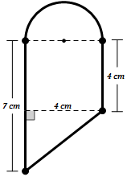
- Find the perimeter of each compound figure below.
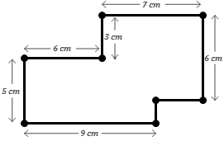
Assume the compound figure includes a semicircle.
- B.

(Assume all adjacent sides are perpendicular.)

10a.
10b.

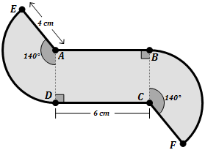
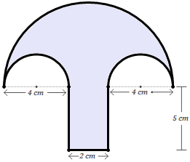
Assume the compound figure includes a rectangle and 2 sectors centered at point A and C respectively.
Assume the compound figure includes three semicircles.
C. D.

10c.
10d.

