3-7a Circles & Volume

Volume of Pyramids & Cones Name:

1. 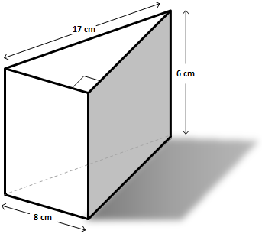**Find the Volume of the following solids (figures may not be drawn to scale).**

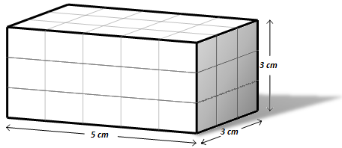

Volume:

Volume:

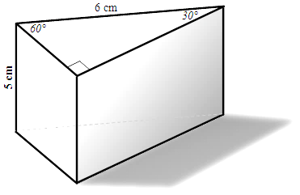

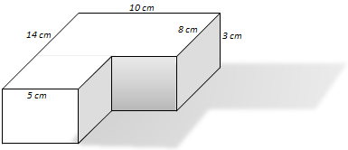

Volume:

Volume:

1. **Find the Volume of the following solids (figures may not be drawn to scale).**

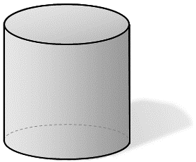

***4 cm***

***12 cm***

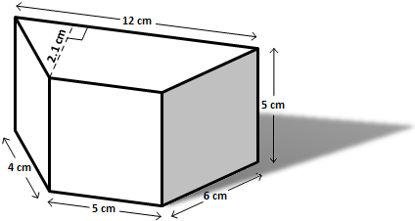

Volume:

Volume:

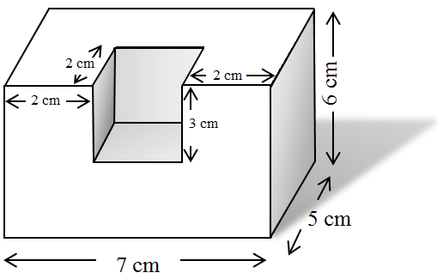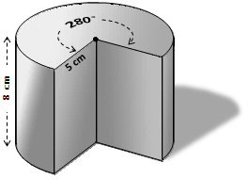

Volume:

Volume:

1. **Find the volume of the following solids (figures may not be drawn to scale).**

Find the volume of 6 pennies stacked directly on top of each other (which is a cylinder). Each Penny: Diameter=19 mm, thickness=1.52 mm

Find the volume of 6 pennies stacked on top of each other, but slanted.

What two things need to be congruent, so that the volume is congruent to #3.

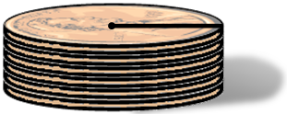

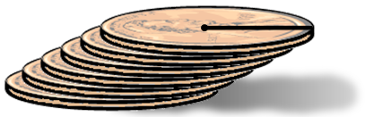

Volume:

Volume:

Find volume of the oblique rectangular prism.

Find volume of the sphere.

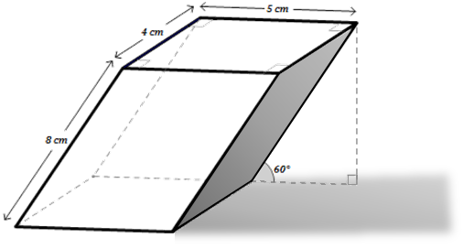

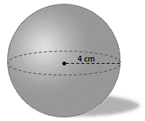

Volume:

Volume:

1. **Find the volume of the following solids (figures may not be drawn to scale).**

The solid below shows a gas tank for a tractor trailer truck. It is in the shape of a cylinder with a radius of 9 inches and a height of 60 inches. How many gallons of fuel will it hold if there are 231 cubic inches in one gallon?

A sphere is inscribed in a cube with a volume of 27 cm3. What is the volume of the sphere?

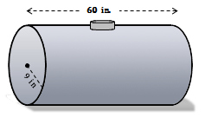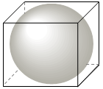

Volume:

Gallons:

*A snowman is created from two spherical snow balls. Given the circumference of each sphere determine the volume of the snowman.*

Find volume of the regular hexagonal prism.

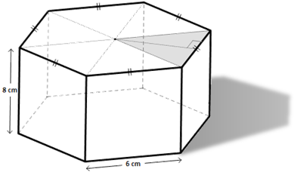

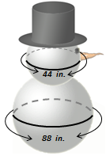

Volume:

Volume: