3-7b Circles & Volume

Volume of Pyramids & Cones Name:

1. **Find the Volume of the following solids (figures may not be drawn to scale).**

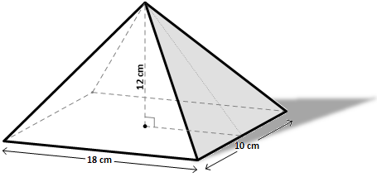

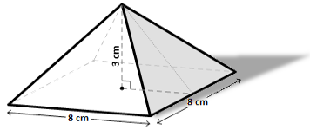

Volume:

Volume:

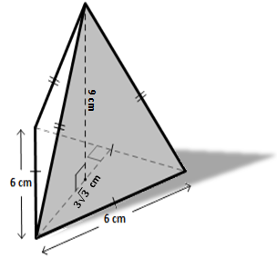

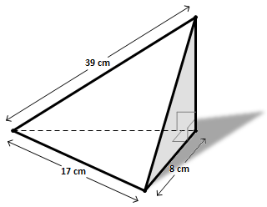

Volume:

Volume:

1. **Find the Volume of the following solids (figures may not be drawn to scale).**

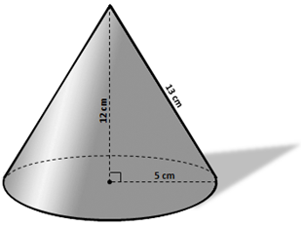

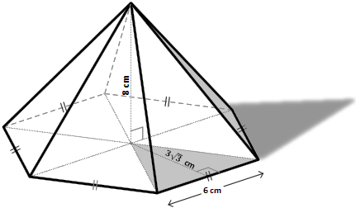

Volume:

Volume:

Find the volume of the irregular solid. The base has an area of 80cm2 and a height of 9 cm.

Find the volume of the regular octahedron.

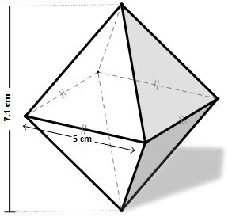

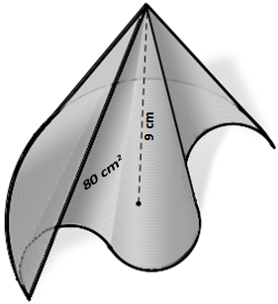

Volume:

Volume:

1. **Find the Volume of the following solids (figures may not be drawn to scale).**

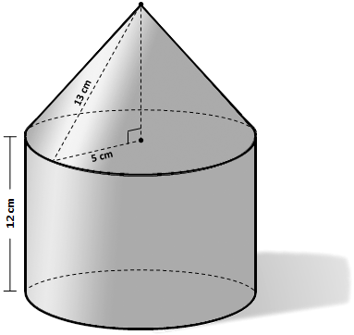

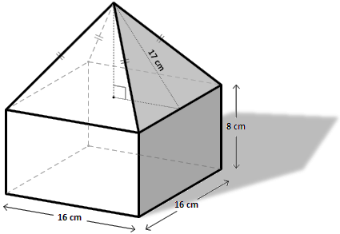

Volume:

Volume:

Consider triangle ABC with vertices at A (0,0), B(4, 6), and C(0,6) plotted and a coordinate grid. Determine the volume of the solid created by rotating the triangle around the y-axis.

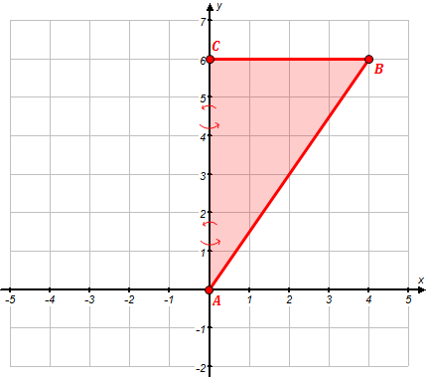

Volume: