# **3QR- 2 Quiz Review Name__________________**

1. Cos β = _________ 4. Cos α= ________

β

**15**

2. Sin β = _________ 5. Sin α = ________

**9**

α

3. Tan β = ________ 6. Tan α = _______

**12**

**Solve for the missing sides using Trig Ratios (sin, cos, tan). Round answers to the nearest tenth**.

7.

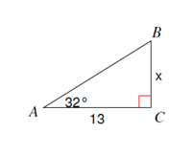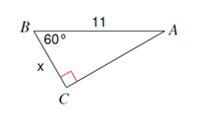

8.

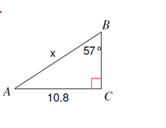

10.

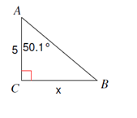

9.

**Find the missing angles using inverse trig. Round answers to the nearest tenth**

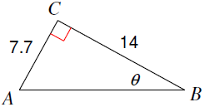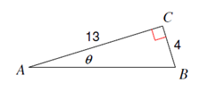

11. 12.

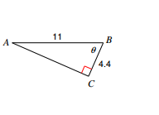

13.

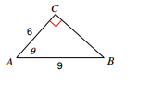

14.

15. (a) Sin 57 ° = Cos _______° (b) Cos 25.3* = Sin _______*

A and B are acute angles in a right triangle.

16. If , **what is cos B? 17. If Tan A is , what is Tan B?**

**Application Problems: Do All Steps**

1. An 8 foot ladder is leaning against a wall so that the base is 5 feet from the base of the wall. What angle does the ladder make with the ground? Round to the nearest tenth.
2. A surveyor is standing 25 feet from a building and is looking at the top with an angle of elevation of 65°. How tall is the building? Round to the nearest tenth.
3. Bob is looking at a helicopter that is flying 1,000 feet above the ground. Bob is 1,500 feet from the helicopter. At what angle of elevation is Bob looking at the helicopter? Round to the nearest tenth.
4. A kite is being flown using 100 yards of string. The kite has an angle of elevation with the ground of 55 degrees. How high above the ground is the kite?