4B-6 – Volume of Pyramids & Cones

**Name:**

1. **Find the Volume of the following solids (figures may not be drawn to scale).**

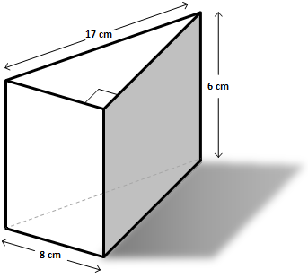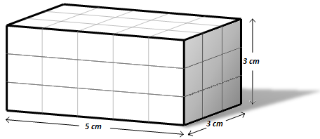

Volume:

Volume:

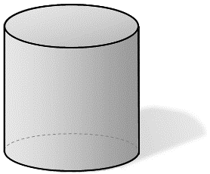

***4 cm***

***12 cm***

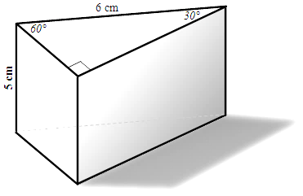

Volume:

Volume:

**Find the Volume of the following solids (figures may not be drawn to scale).**

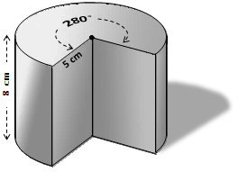

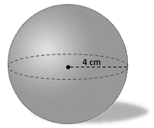

Volume:

Volume:

A sphere is inscribed in a cube with a volume of 27 cm3. What is the volume of the sphere?

A snowman is created from two spherical snow balls. Given the circumference of each sphere determine the volume of the snowman.

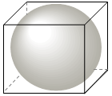

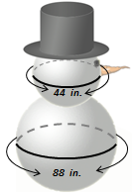

Volume:

Volume:

**Find the volume of the following solids (figures may not be drawn to scale).**

6 pennies are stacked directly on top of each other (which is a cylinder). The diameter of a penny is 19.05 mm and each penny is 1.52 mm thick. Find the volume of the whole stack.

6 pennies are stacked on top of each other, but slanted. Find the volume of the stack.

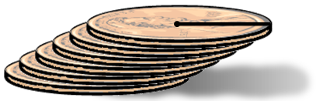



Volume:

Volume:

The solid below shows a gas tank for a tractor trailer truck. It is in the shape of a cylinder with a radius of 9 inches and a height of 60 inches**. How many gallons of fuel will it hold** if there are 231 cubic inches in one gallon?

Find volume of the oblique rectangular prism.

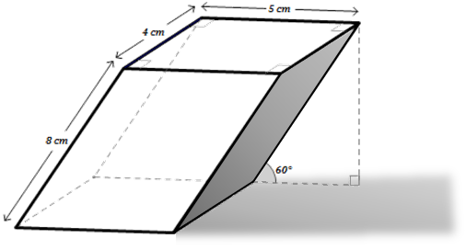

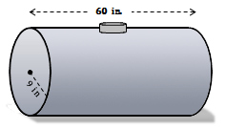

Volume:

Volume:

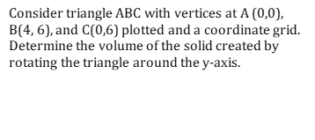

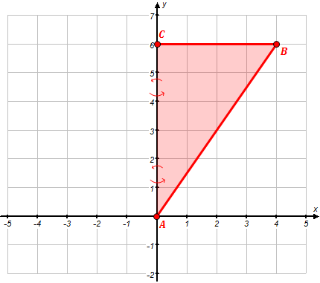

C:\Users\kcd18501\AppData\Local\Microsoft\Windows\INetCache\Content.MSO\CD2D64D0.tmp