Find the volume of each composite figure. Round to the nearest tenth.
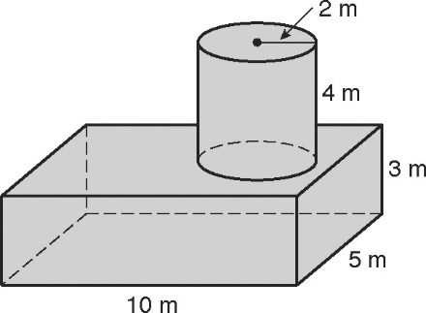
6..

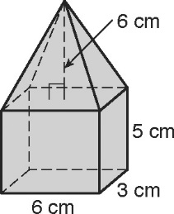
7.

8.. Hint: To find the volume, subtract the volume of the hemisphere from the volume of the cylinder.

