**4C-3 Name_________________________________________**

**Arc Length Practice**

***Find the length of each major or minor arc. Report your answer in terms of pi and as a decimal approximation rounded to the nearest tenth.***

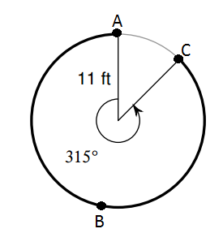1. Find the length of  . _______________________________________

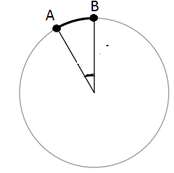2.  ; diameter = 12 in ; Find the length of  . _________________________________

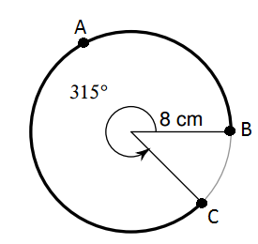3. Find the length of  . _______________________________________

4. Diameter = 9 in; Find the length of  . _______________________________________

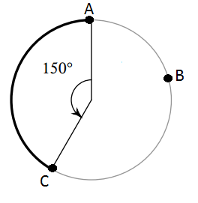

***Find the radius of each circle. Round to the nearest whole number.***

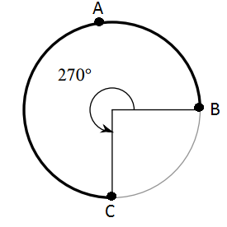5. The length of  is 61.3 feet. Find the radius. _________

6. The length of  is 49.7 feet. The central angle that intercepts  .

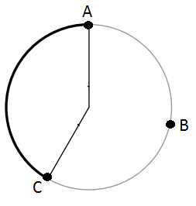 Find the radius. __________

***Find the measure of each central angle. Round to the nearest degree.***

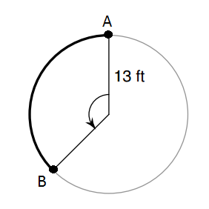7. The length of is 30.6 meters. Find the measure of the central angle that intercepts.

__________

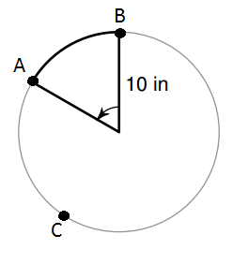8. The length of is 10.5 cm. Find the measure the central angle that intercepts .

__________