**Name___________________________________**

**Area of Sectors Practice**

***Find the area of each shaded sector. Report your answer in terms of pi and as a decimal approximation rounded to the nearest tenth.***

1. Find the area of sector *BAC*. _______________________________

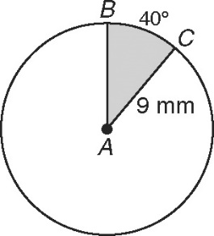

2. Find the area of the shaded sector. _______________________________

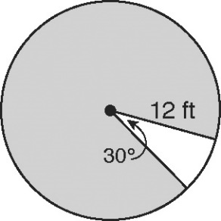

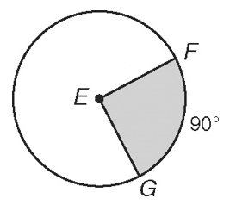3. The diameter of circle E is 20 mm. Find the area of sector *FEG*. _______________________

.

***Find the radius or the measure of the central angle. Round to the nearest whole number.***

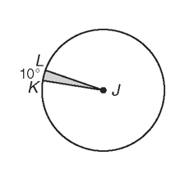4. The area of sector *KJL* is . Find the radius. _________

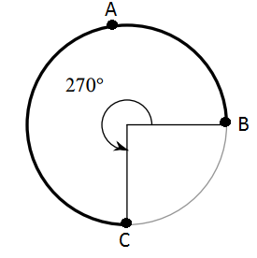

5. The area of sector *UTV* is . Find . __________

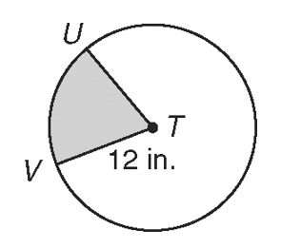

6. The area of sector *FEG* is . Find . __________

