Name __________________________________ Period__________ Date_________

**Find the slope** of each line. Write parallel, perpendicular, or neither for each pair.

**Show all work to support your answer.**

1.   m=  m= 5. ___________________

1.  m=  m= 6. ___________________

3.  m=  m= 7. ___________________

**SHOW ALL WORK & Circle answers**

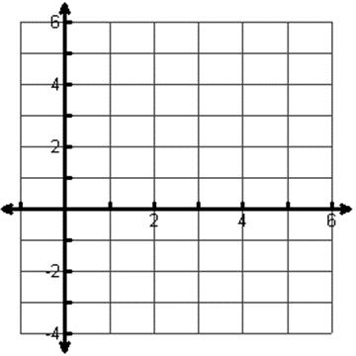

4. Find the perimeter of the triangle ABC (Draw)

A (1, –3), B (2, 2), C (4, -1)

P=



5.. Find the perimeter of the triangle ABC (Draw)

A (0, -3), B (0, 3), C (4, 0)

P=

Round each coordinate to the nearest **tenth** if needed.

6. Given the points C(-5, -4) and D(5, 1), find the coordinates of the point P on directed line segment  that partitions  in the ratio 2:3.

7. Given the points F(–5, 1) and G(3, -6), find the coordinates of the point P on directed line segment  that partitions  in the ratio  (find the ratio first)

8. Find the coordinates of point P, that lies  of the way on the directed line segment PQ, where P (-3, 11), and Q ( 9, -5)

9. Write the equation of the line that is:

a) parallel to , through  b) perpendicular to, through 

1. a)  b)  c) 

C ( , ) r = C ( , ) r = C ( , ) r =

**Graph the following circles. State the center and radius.**

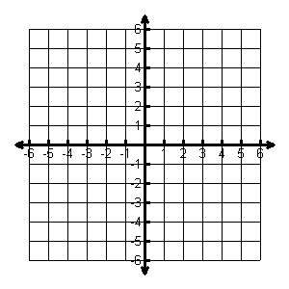2. 

Center: _______

Radius: ______

1. 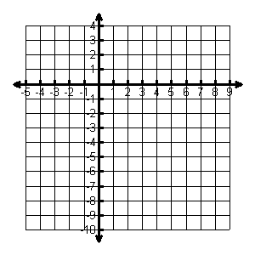

Center: _______

Radius: ______

**Write the standard equation for the circle. State the center and radius.**

1. 
2. 

Eq: ___________________

Center: ________________ R = _________

Eq: ___________________

Center: ________________ R = _________

7. Jet’s Pizza advertises free delivery within a 10 mile radius. If a customer lives 9 miles east and 8 miles south of Jet’s, do they qualify for free delivery?

8. Write the equation for each circle

A. Center: (3, - 8) B. Center: (2, 6) C. Center: (-4, 0)

Radius: 5 Radius: 4 Radius: 2

Bonus:

9. Write the equation for each circle

A. Center: (2, 1) Through (-1, 1)

B. Diameter Endpoints are (2, 6) and (-4, 6) C. Tangent at (-2, 0) and tangent at (0,-2)

