Name: __________________________________ Date: __________________

1. a)  b)  c) 

C ( , ) r = C ( , ) r = C ( , ) r =

**Graph the following circles. State the center and radius.**

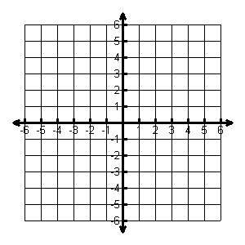2. 

Center: _______

Radius: ______

1. 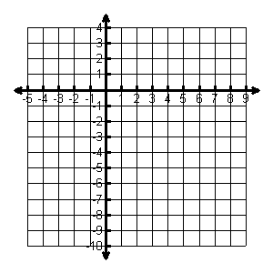

Center: _______

Radius: ______

**Write the standard equation for the circle. State the center and radius.**

1. 
2. 

Eq: ___________________

Center: ________________ R = _________

Eq: ___________________

Center: ________________ R = _________

7. Jet’s Pizza advertises free delivery within a 10 mile radius. If a customer lives 9 miles east and 8 miles south of Jet’s, do they qualify for free delivery?

8. Write the equation for each circle

A. Center: (3, - 8) B. Center: (2, 6) C. Center: (-4, 0)

Radius: 5 Radius: 4 Radius: 2

Bonus:

9. Write the equation for each circle

A. Center: (2, 1) Through (-1, 1)

B. Diameter Endpoints are (2, 6) and (-4, 6) C. Tangent at (-2, 0) and tangent at (0,-2)

