### Name: _________________________________ Per__________ 5A-6 Partition Segment

|  |
| --- |
| Partitioning Segments |

Find the point that partitions the segment with the two given endpoints with the given ratio. **(Round to the nearest tenth if needed.)**

1. (1, 2) 2:1 (7, 5) 2) (6, 2) 3:1 (-10. -6)

3)(-7,-3) 2:3 (8, 7) 4) (2, -1) 1:2 (-3, -5)

5) (4, 6) 1:3 (-3, -2) 6) (-15, -10) 4:1 (5, -5)

7)  of the way between (4, 6) and (-3, -8) 8)  of the way between (-15, -10) and (3, 5)

Ratio___________ Ratio___________

**Plot points H and C and then find the coordinates of point T.**

9) Find the coordinates of T that partitions H(2, 1) to C(8, 10) in a 1:2 ratio.

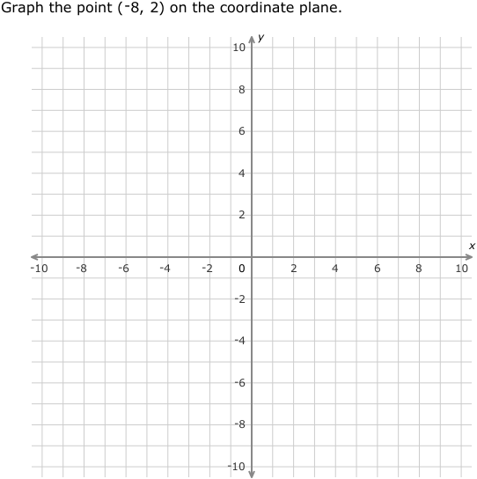

10) Find the coordinates of T that partitions H(-3, -5) to C(7, 10) in a 2:3 ratio.

