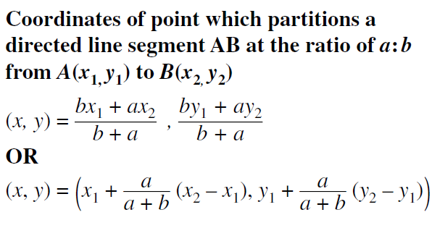**5A Partitioning Line Segments NOTES** Name_____________________________

**Midpoint Formula = **

The **midpoint** divides or “**partitions**” a segment in **half**, so the lengths have a **ratio** of **1 : 1.**

1. A is at -2 and B is at 7. Find the point, T, so that T partitions A to B in a 1:2 ratio.



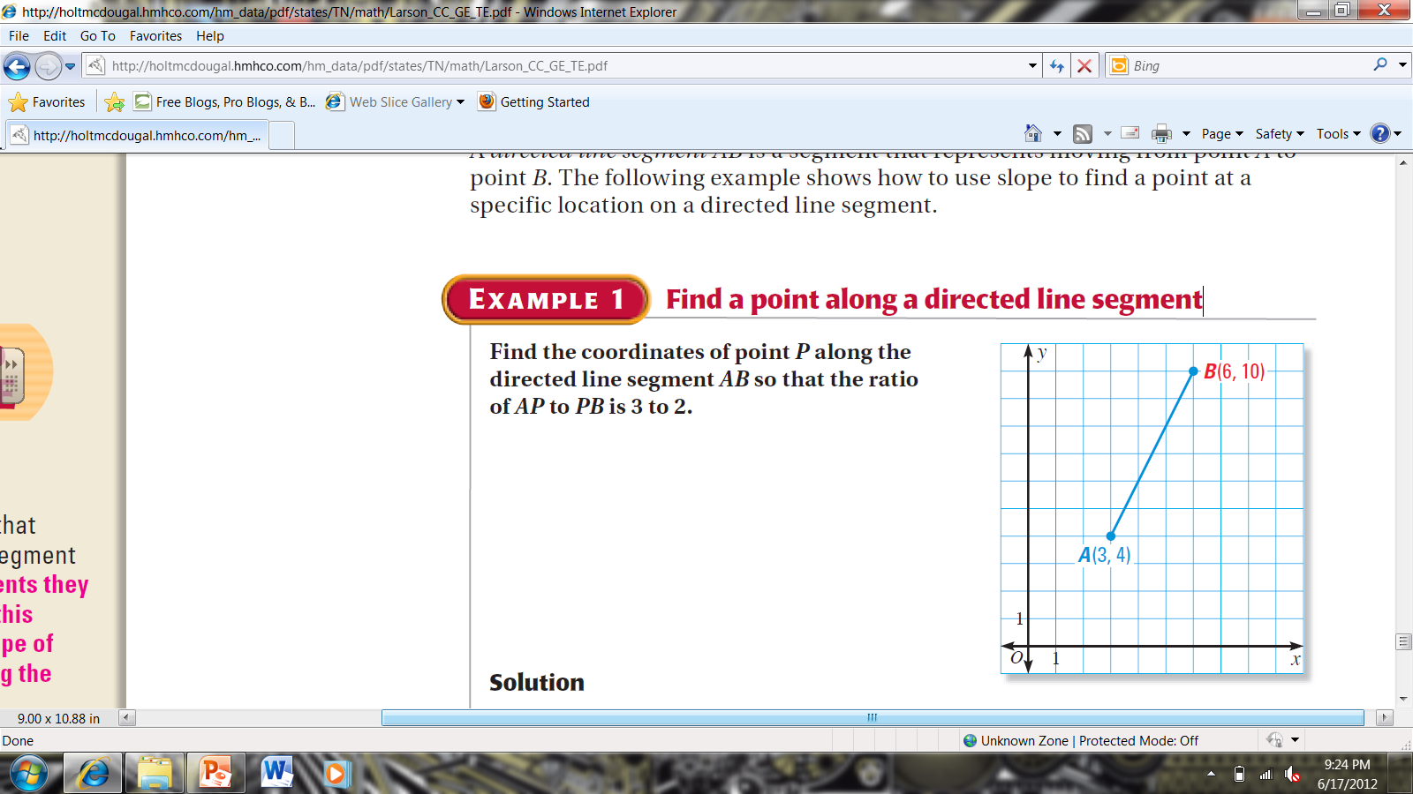

Find the point P that partitions AB in a ratio of 1:2

Point P is ________(fraction) of the way from A to B.

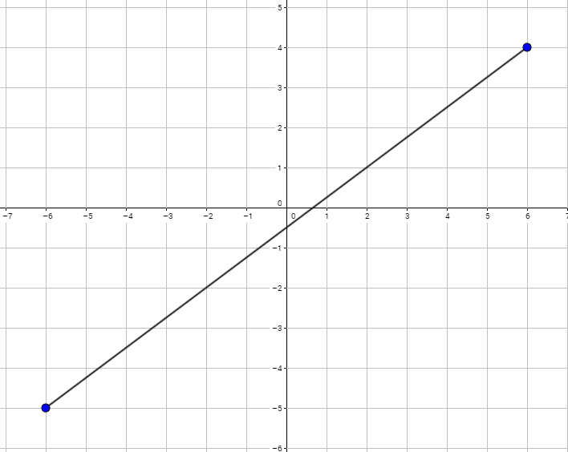 Find the point  of the way from M to N.

What is the ratio? ________

M = _______ P=_______

Point __________

1. Find the midpoint of $\overline{AB}$, where A(-12, 18) and B(-6, 24). Ratio = ________

Point___________

2. Find the point P that partitions the line segment $\overline{AB}$ in the given ratio.

  Ratio 1 : 3

Point ________

3. Find the point that is  the distance from the endpoint (-4, -6) of the segment with endpoint (-4, -6) and (2, 9). Ratio = ________

Point ________