Name __________________________________ Period__________ Date_________

Write the equation of the line that satisfies the conditions. **(Show all work, and circle answers)**

|  |  |
| --- | --- |
| 1. passes through (8,2)   and Parallel to | 1. Passes through (-12, 2)   and Parallel to |
| 1. Passes through (4, 6)   and Perpendicular to | 1. Passes through (10, 3)   and Perpendicular to |

**Find the slope** of each line. Write parallel, perpendicular, or neither for each pair.

**Show all work to support your answer.**

1.    5. ___________________

1.   6. ___________________

7.   7. ___________________

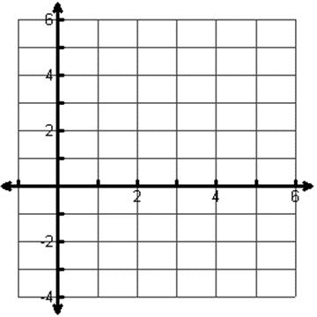**SHOW ALL WORK & Circle answers**

8. a. Find the perimeter of WXYZ.

(Round your answers to the nearest tenth)

W (0, 0) X (1, 3) Y (4, 2) Z (3,-1)

b. Circle each of the following shapes that describe WXYZ? How do you know?

Parallelogram Rectangle Square Rhombus Equilateral Triangle



9. Find the perimeter of the triangle ABC (Draw)

A (0, –4), B (0, 2), C (3, 0)

Bonus: Find the area of the triangle.



. 10. Find the perimeter of the Quadrilateral DEFG (Draw)

D (-1, -2), E (1, 1), F (3, 1) G (1, -2)



11.. Find the perimeter of the triangle ABC (Draw)

A (0, -3), B (2, 3), C (5, 2)