6-5 Two-Way Tables: Name:_________________________
Determine if the events are independent.
- Events: Joe drives to work, and started keeping track of the weather on days when he is late. Is being On-Time for Joe dependent on the rain?
 | On-Time (OT) | Late (L) | Total Days
Rain (R) | 3 | 7
No Rain (NR) | 31 | 9
Total

P(R) = P(L) =

P(R) $×$ P(L) = P(R$∩$L) = Ind. or Dep.
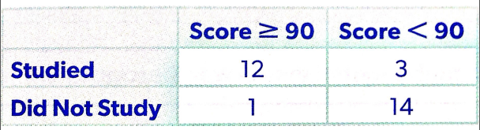
- Events: Being in the 4th grade and Owning a dog
 | Dog (D) | Cat (C) | Total Days
4th grade | 35 | 15
5th grade | 14 | 6
Total

P(4th) = P(D) =

P(4th) $×$ P(D) = P(4th $∩$ D) = Ind. or Dep.
3. Events: Being in the 12th grade and drive to school.
 | Drive to school (Yes) | Do not drive to school (No) | Total Days
12th grade | 73 | 27
11th grade | 42 | 58
Total

P(12th ) = P(Yes) =
P(12th ) $×$ P(Yes) = P(12th $∩$ Yes) = Ind. or Dep.

Complete the table and find the following probabilities:
4. Events: Domestic flights and on-time.
 | On-Time (OT) | Late (L) | Total Days
Domestic (D) | 110 | 10
International (Int) | 264 | 24
Total

P(D) = P(OT) =

P(OT $∪$ Int.) =

P(Int. $∪$ L) =

P(D $∪$ OT) = Shade the table above: D$∩$ L

Shade the Venn diagrams.
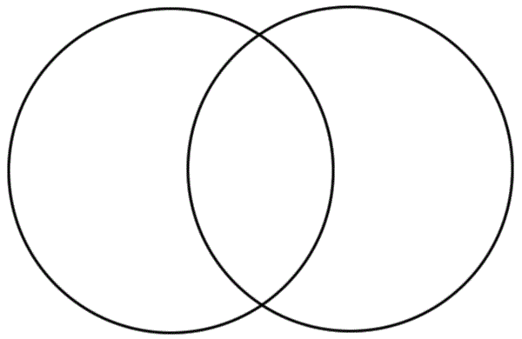

A
B

A
B

$A∩B$ $A∪B$

