**11. Find the volume of the rectangular prism shown below**



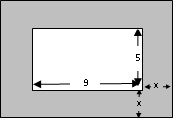**12. Describe the area of the shaded region as a polynomial**

**13. Multiply the following:**

a. b. 

**FACTOR the following:**

14.  15. 

16.  17. 

Name each polynomial. (2 names each)

18.  19.  20.  21. 

Add or Subtract.

22.  23. 