Name_____________________________________ Block______

**Unit 5B Review PART 2**

Do ** problems without a calculator

1. What is the center of the circle given by the equation ? ( , )
2. **Is the point (6, -5) on a circle with a center of and a radius of 5?
3. Convert the equation  to standard form. 
4. Circle ***P*** has a center at (-3, 5). (5, -1) is a point on circle ***P.***

Is (-3, -5) a point on the circle, in the circle, or outside the circle?

Is (-13, 5) a point on the circle, in the circle, or outside the circle?

Is (-3, 10) a point on the circle, in the circle, or outside the circle?

1. Which is the graph of the circle represented by the equation  ? Circle _____

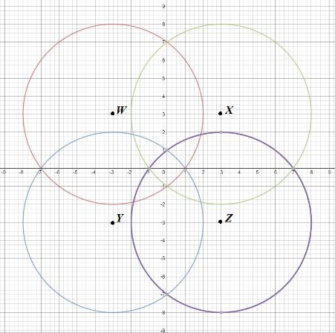

1. Write the equation of a circle with center (1, 5) and diameter 8. 
2. **Write the equation of a circle with a center at (0, -5) and a radius of 4. 
3. **Consider a circle with center (-1, 3) and a point on the circle (x, y). Which of the following represents the radius of the circle?
   1. 
   2. 
   3. 
   4. 
4. **A diameter of a circle has endpoints at (-3, 0) and (-3, 10).

*(Graph to determine the center and radius.)*

What is the equation for this circle in standard form?

What is the equation for this circle in general form?

1. Point  is on a circle with center . What is the radius of the circle? r = __________
2. A student mistakenly wrote the following equation for the graphed circle: 

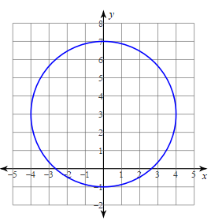 Explain the parts of the equation that are **incorrect**.

________________________________________________

________________________________________________

________________________________________________

________________________________________________

________________________________________________

________________________________________________

________________________________________________

________________________________________________

Unit 5B Review Part 3 Name_____________________________________

12. Write the standard form equation for the circle with a center at and a radius of 4.

13. Write the standard form equation for the circle with a center at $(-3, -6)$ and a radius of  .

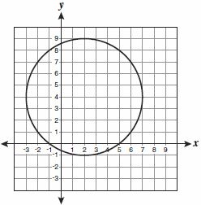14. Write the standard form equation for each graphed circle.

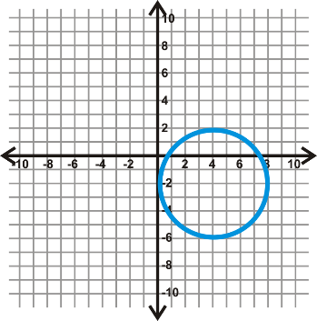

15. Write the standard form equation for the circle with center (-2, 4) and point (0, -4) on the circle.

16. Does the point (13, 16) lie **on, inside, or outside** circle *O* with center (7, 8) and radius 10? Explain.

17. What is the center and radius of the circle given by the equation  ?

18. What is the center and radius of the circle given by the equation  ?

19. What is the center and radius of the circle given by the equation  ?

20. Convert the equation to general form.

21. What is the center and radius of the circle given by the equation ?

22. ** A diameter of a circle has endpoints at (0, -3) and (10, -3). Write the equation of the circle in general form.

Unit 5B Review Part 1 Name_______________________________

23. Write an equation for every circle in the picture below.

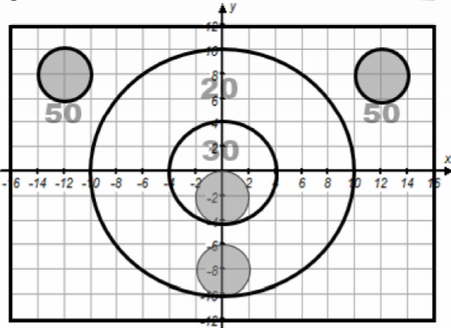

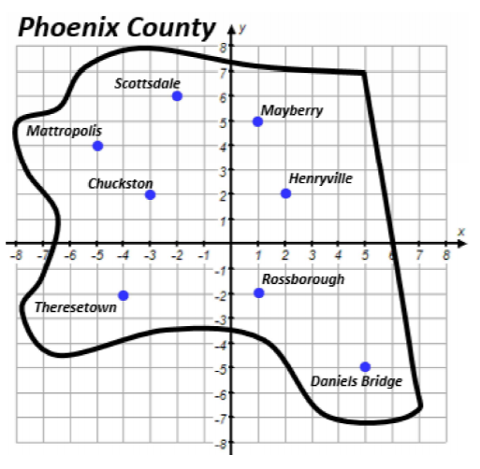24. List all the cities in or on the circle given by the equation: 

25. A circular disk drive has a diameter with endpoints at (3, -4) and (3, 2). Find the center and radius of the disk drive. Write the equation of the circle in standard form.

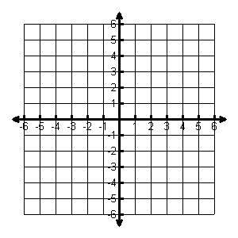

Center: ______________

Radius: ______________

Equation: _______________________

26. Circle C has a center of (-2, 1) and a radius of 6. Does the point (-4, -4) lie on circle C? Show all work to prove.



Statement with reason:

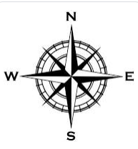27. Jet’s Pizza is at (0, 0) and advertises free delivery within a 5-mile radius. If a customer lives 4 miles west and 4 miles south of Jet’s, do they qualify for free delivery? Show your work.



Statement with reason:

