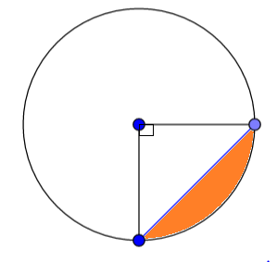**Areas of Segments of Circles**

**Area of the Segment = Area of the sector – Area of the triangle**

|  |  |  |
| --- | --- | --- |
|  |  |  |
|  |  |  |