16. A & B are complementary. If Sin(A) = 3/11, what is Tan(B)? You answer can be decimal or fraction.

17. If Cos(θ) = 7/8, find Sin(90 - θ).

18. G A) What trig function is equivalent to Sin(G)___________
B) If tan(G) = 3/11, then tan(H) = ___________
H
19. Sally is sitting 19ft from a wall and holding a rope that’s attached to the top of the wall. The angle of elevation between the rope & ground is 79°. How long is the rope?

20. A certain airplane is capable of a steady 26° climb. When the jet is 900ft in altitude, how many feet has it travelled through the air (diagonally)?

21. Sally is flying a kite at an angle of elevation of 43°. Her hands are 1m above the ground. If 35m of string have been let out, how high is the kite?

22. When the sun is 68° above the horizon, a pole casts a shadow that’s 85in long. How tall is the pole?

23. A 32ft tall ladder is leaning against a wall. If the ladder contacts the wall at a point 27.5ft above ground, what’s the measure of the angle between the ladder and wall?

24. Sally’s brother is in a tree house looking down. At a 19° angle of depression, he sees a dog. If the treehouse is 12ft high, how far away is the dog from the base of the tree?

25. Find the angle of elevation of the sun if a 120ft tall cellphone tower is casting a shadow that’s 195ft long.

26. Point M is at (3, 7). Point N is at the origin (0, 0). What’s the measure of the angle formed by $\overline{MN}$ and the x-axis?

27. If the diagonal of a certain square is 6√2, what’s the area of the square?

28. The perimeter of a certain equilateral Δ is 42. What’s the exact length of the altitude of the triangle?

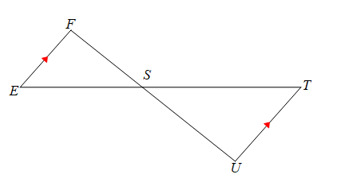
29. Given: $\overline{EF}||\overline{TU}$
Prove: ΔEFS ≅ ΔTUS

