Name:__________________________________
Quiz 1 Reivew Date:___________________Block:___________
Venn Diagrams, Mutually Exclusive/Overlapping

Using the information below, construct a Venn diagram and answer the probability questions. SHOW ALL WORK.

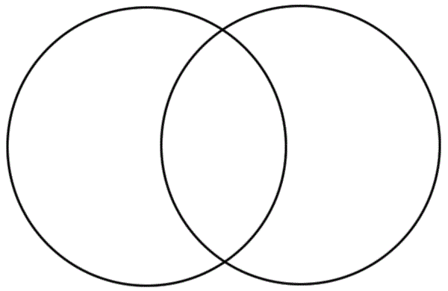
In a survey of 50 people, 22 people said they liked hotdogs, 27 people said they liked tacos, and 7 people said they liked both tacos and hotdogs.

1. Fill in and label the Venn diagram.

Answers: 3 decimal places

- What is the probability that a person chosen at random
likes hotdogs? 2.___________

- What is the probability that a person chosen at random likes tacos and hotdogs? 3.___________

- What is the probability that a person chosen at random likes tacos or hotdogs 4.___________

- What is the probability that a person chosen at random does not like hotdogs? 5.___________

The Venn Diagram below shows the number of people in the cafeteria. Some students ate a ham sandwich (H) and some had a cookie (C) for dessert.

- How many people are in the cafeteria? 6.___________
H
C
26
20
24
10
- P (H) 7.___________
- P (H ∩ C) 8.___________
- P (H ∪ C) 9.___________
- P (C)’ 10.___________

11. In a bowl of marbles, there are 6 red ones, 8 green ones, and 10 blue ones.
Pick 2 marbles.

- With replacement: P(blue and green) ____________

- With replacement. P(green and red) ___________

- Without replacement. P(red and blue) ___________

- What is the probability of choosing two red marbles. (Hint: same as P(red and red) without replacement.)
____________

The following events are independent.

12. P(A) = 0.3 P(B) = 0.7 P(A and B) = ____________

13. P(A) = 0.45 P(B) = 0.2 P(A and B) = ____________

14. Complete the Two-Way Frequency Table below.
A survey of 150 men and 160 women about their lunches. Of those surveyed, 45 men and 95 women said they brought a lunch to work. The others did not bring a lunch.
 | Bring Lunch | Not Bring Lunch | Total
Men
Women
Total

