1. Find the **area** of the triangle. A = ½ bh 2. Find the **area** of the triangle. A = ½ bh

15 ft

29°

x

x

26°

12 m

1. **Multiple Choice:** In the diagam to the right, RN ≠ TN. Which statement about triangle RTN is false?

R

T

N

1. sin R = cos T B. sin T = cos R C. tan R = $\frac{1}{\tan{T}}$ D. sin R = cos R
2. **Which of the following is equal to cos 28º?**
3. **sin 28º B. sin 62 C. sin 72º D. sin 152º**
4. **The top of a lighthouse is 80 feet above sea level. The angle of elevation from a fishing boat to the top of the lighthouse is 5°. Which is closest to the distance between the boat and the base of the lighthouse?**
5. **857 ft**

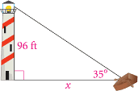

1. **75 ft 75 feet**
2. **7 ft**
3. **494 ft**
4. **A package of food will be dropped from an airplane to a target on the ground, where a group of campers will retrieve it. The altitude of the plane is 700 meters. The angle of elevation to the plane is 15°. To the nearest meter, what is the horizontal ground distance between the plane and the target?**

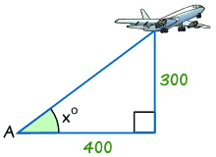

700 m

15°

x



1. **188 m**
2. **711 m**
3. **2,612 m**
4. **4,031**
5. 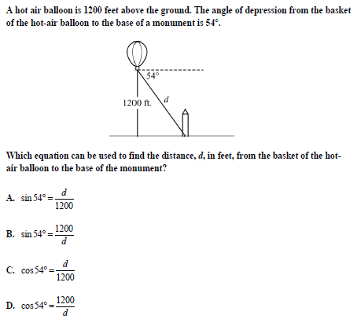

What is the distance from the balloon to the monument? Set up trig equation, but do not solve. Use the letter d.

1. Triangle ABC is similar to triangle A’B’C’. To the nearest tenth, what is the length of $B^{'}C^{'}$?

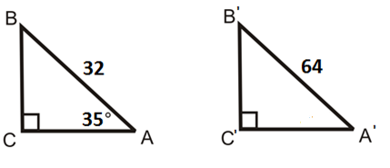

48

24

1. Triangle ABC is similar to triangle A’B’C’. To the nearest tenth, what is the length of $B^{'}C^{'}$?



28

14

20

1. Each side of an equilateral triangle measures 20 cm.

a

Find the length of an altitude, *a*, of the triangle.

1. As shown below, in . $sinA=\frac{8}{17}$ (Answer are **fractions**)

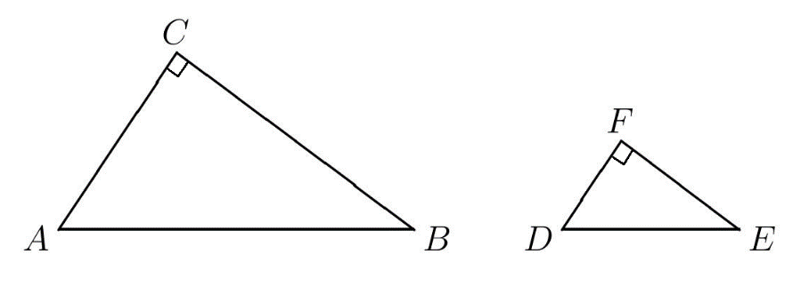

1. Find the ratio for cos A. ____________(fraction)
2. Find the measure of  ____________(degrees)