## R 1-1 Transformations Name _________________________Per______

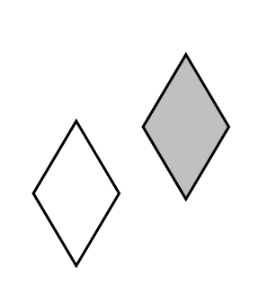Determine whether or not each transformation is an isometry. If so, identify the type of transformation. (Preimages are unshaded and images are shaded.)

1. 2. 3. 4.



5. Which one of the images can be rotated to match the letter ***J*** on the left?

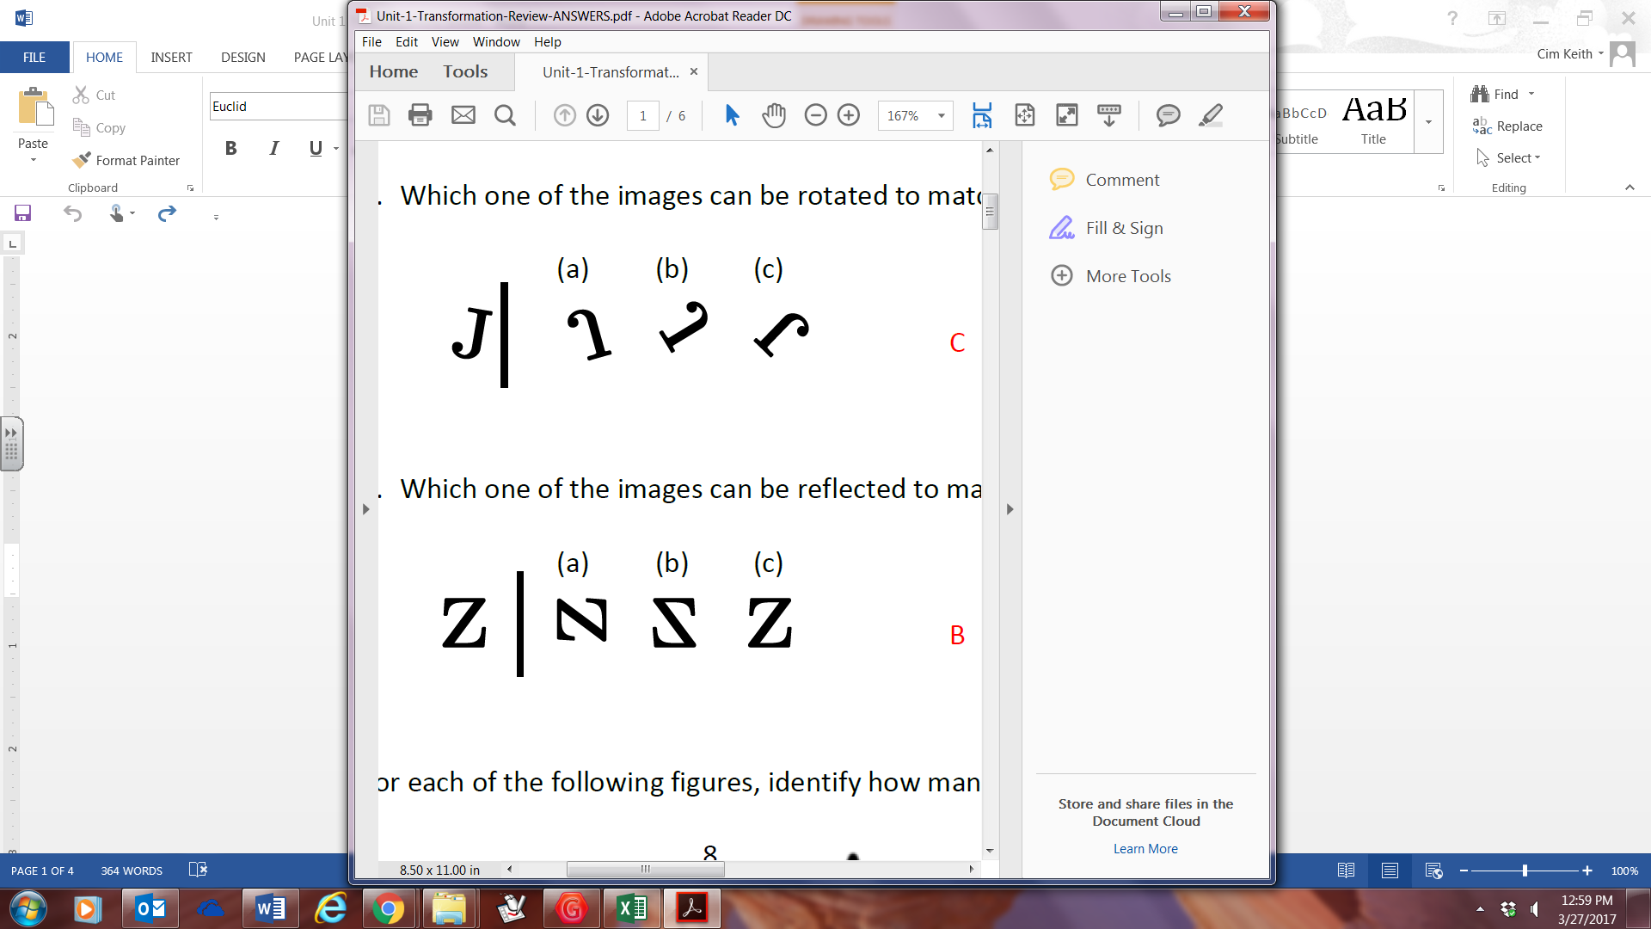

6. Which one of the images can be reflected to match the letter ***Z*** on the left?



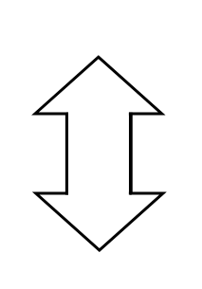For each of the following figures, identify how many lines of symmetry each appears to have

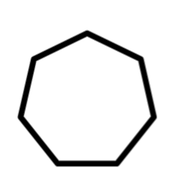

7. 8. 9. 10.

For each of the following figures, determine the degree of rotation that will result in the figure being mapped onto itself, and identify the order of rotational symmetry



11. 12. 13. 14.

For each of the following vertices of a pre-image, find the coordinates of its image after the given transformation occurs

21. A(3, -7) Reflection across the *y*-axis

22. B(-4, 12) Rotation 90o counterclockwise about the origin

23. C(1, -9) Reflection across the line *y* = *x*

24. D(-14, 8) Reflection across the x-axis

25. E(5, 16) Rotation 180o about the origin

26. F(-10, 2) Rotation 90o clockwise about the origin

27. G(7, -15) Reflection across the line *y* = -*x*

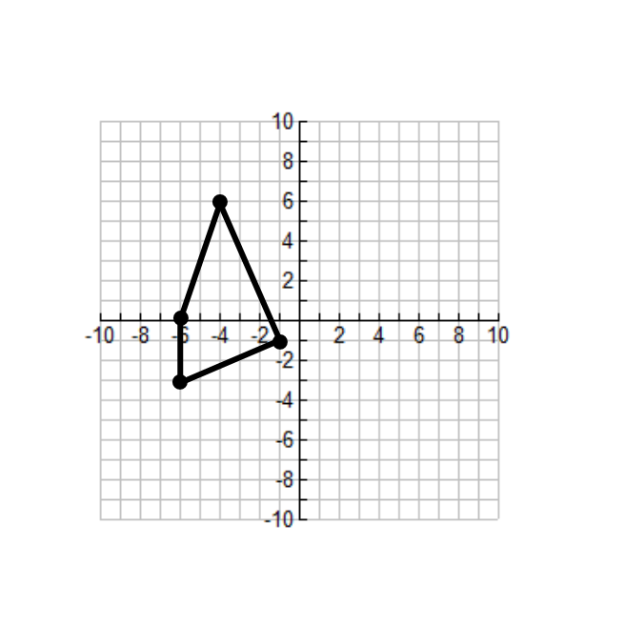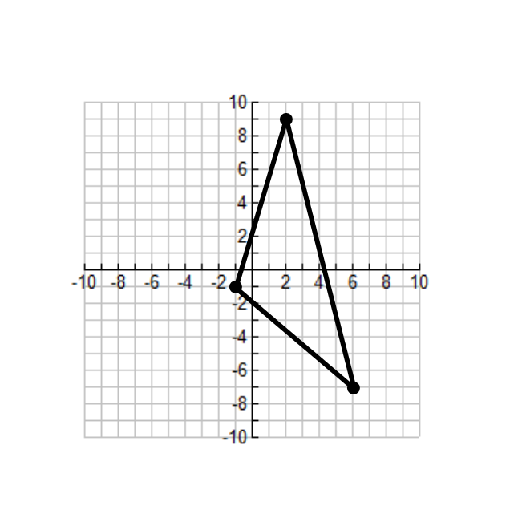Using each pre-image and the given transformation, plot the image on the coordinate plane

28.  29. 

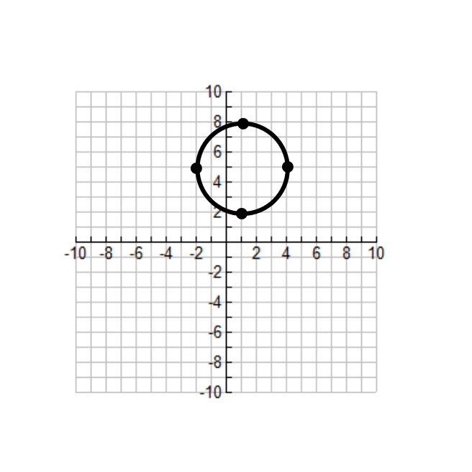

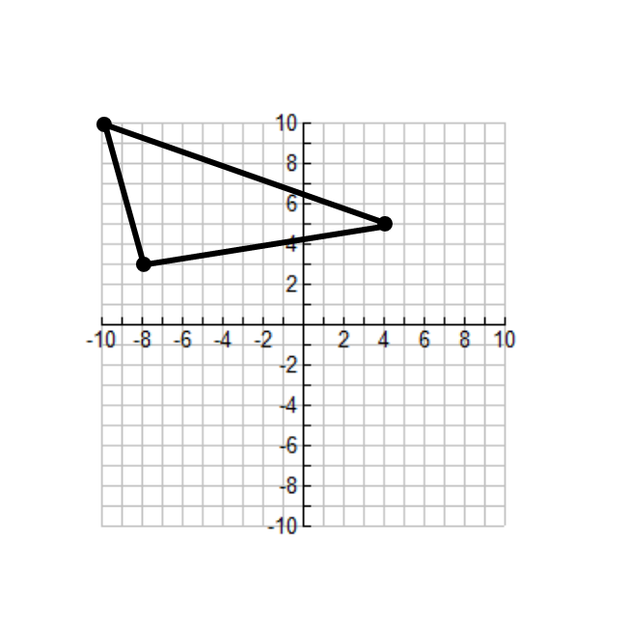30. Reflection across the line *x-axis.* 31. Reflection across the *x*-axis

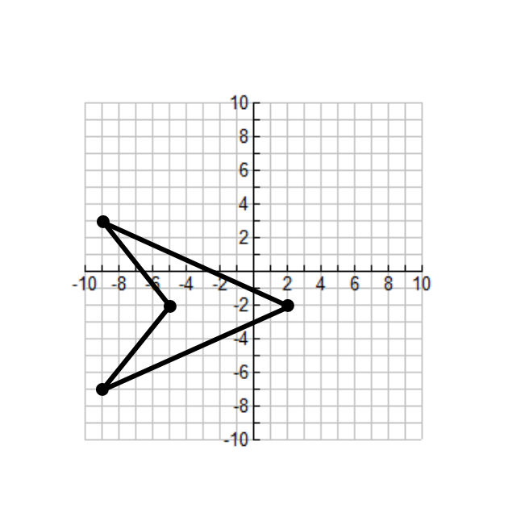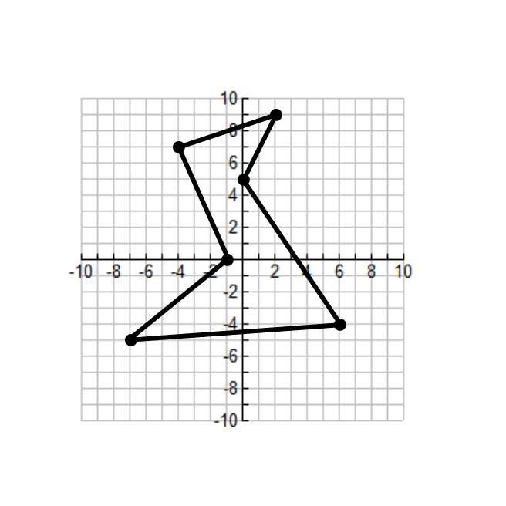32. Reflection across the line *x* = -2 33. Reflection across the *y*-axis

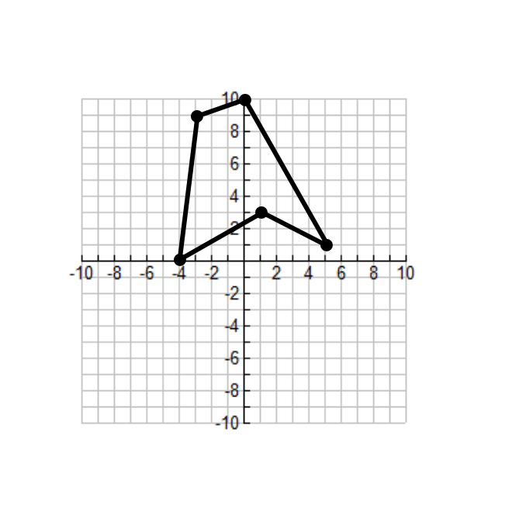

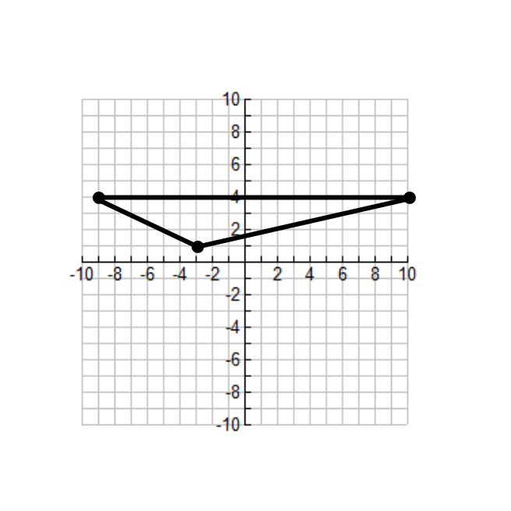

34. Reflection across the line *y* = *x* 35. Reflection across the line *y* = 3

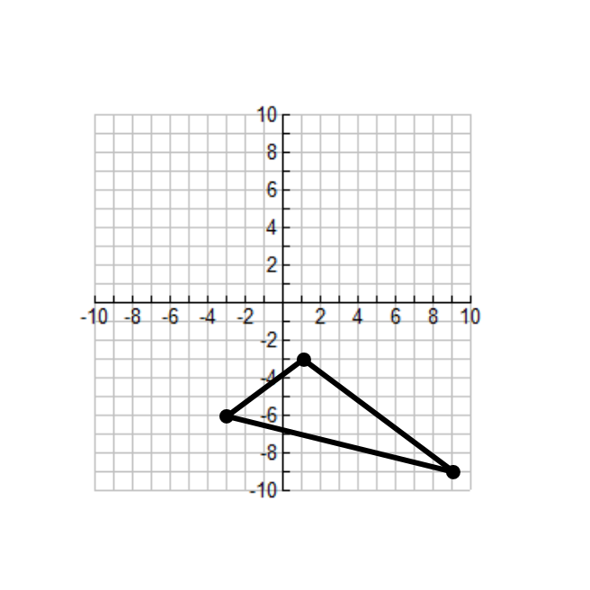

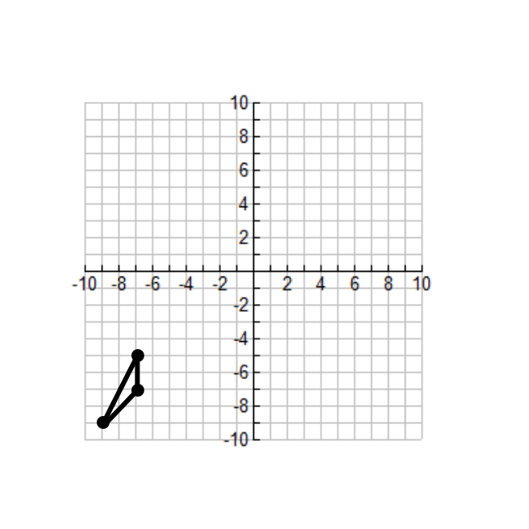36. Rotation 90o counterclockwise 37. Rotation 180o about the origin

about the origin

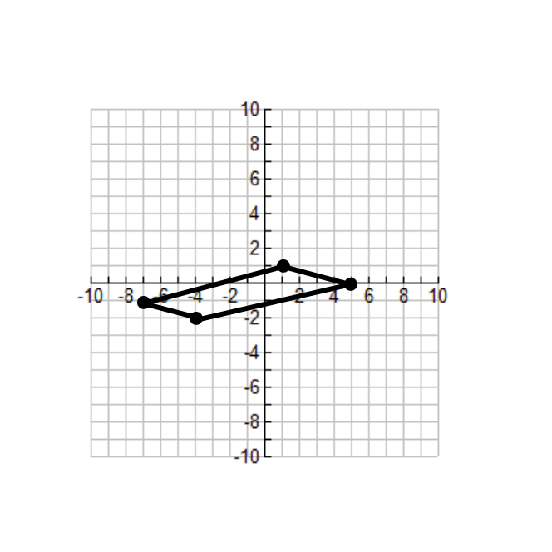39. Rotation 90o clockwise about the origin

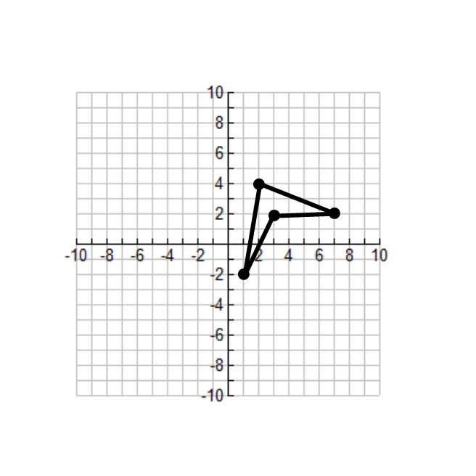

40. Reflection across the line *y*-axis

Rotation 90o clockwise about the origin

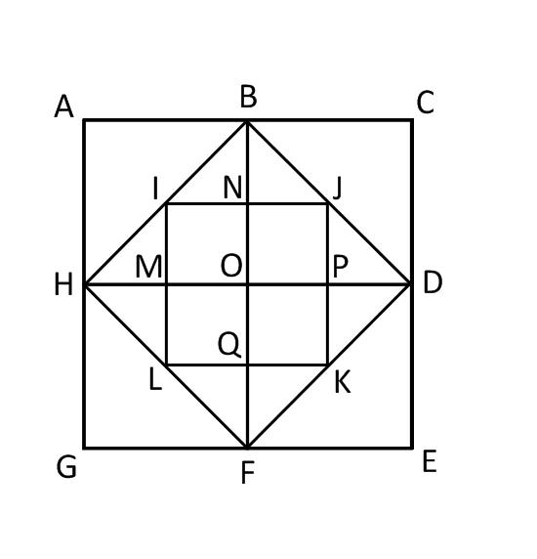Find the image of the segment or triangle.

15. 90° clockwise rotation of  about *O*

16. 90° clockwise rotation of  about *O*

17. 90° counterclockwise rotation of  about *O*

18. 90° counterclockwise rotation of  about *O*

19. 180° rotation of  about *O*

20. 180° rotation of square *NJPO* about *O*