R2-2 Geometry – Similar Figures Name:

**Two figures are considered to be SIMILAR if the two figures have the same shape but may differ in size. To be similar by definition, all corresponding sides have the same ratio OR all corresponding angles are congruent. Alternately, if one figure can be considered a transformation *(rotating, reflection, translation, or dilation)* of the other then they are also similar.**

**Two triangles are similar if one of the following is true:**

1. **(AA) Two corresponding pairs of angles are congruent.**

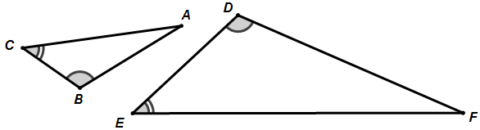

**∆ABC ~ ∆FDE**

*Notice that in the similarity statement above that corresponding angles must match up.*

1. **(SSS) Each pair of corresponding sides has the same ratio.**

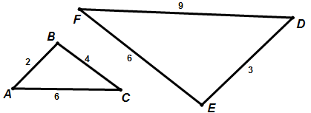

**∆ABC ~ ∆DEF**

$\frac{EF}{BC}= \frac{DE}{AB}= \frac{FD}{CB}=$

1. **(SAS) Two pairs of corresponding sides have the same ratio and the angle between the two corresponding pairs the angle is congruent.**

**∆ABC ~ ∆FED**

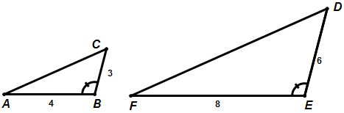

$\frac{FE}{AB}= \frac{ED}{BC}=$

$$∡B ≅ ∡E$$

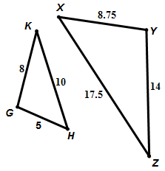**Determine whether the following figures are similar. If so, write the similarity ratio and a similarity statement. If not, explain why not.**

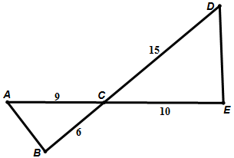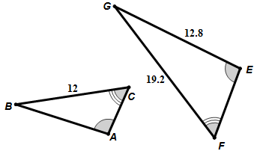

1. **2. 3.**

**Assuming the following figures are similar use the properties of similar figures to find the unknown.**

x =

y =

1. 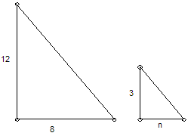 **5. 6.**

n =

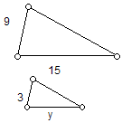

2*x* – 4

3

4

*x* + 3

x =

**7. 8.**

t =



9

8

18

t

x



3

7

18

1. **Given the similarity statement ∆ABC ~ ∆DEF and the following measures, find the requested measures. It may help to draw a picture.**

* **AB = 8**
* **AC = 10**
* **DE = 20**
* **EF = 30**

$m∡ABC=40°$

$m∡EFD=30°$

1. **Find the measure of DF =**
2. **Find the measure of BC =**
3. **Find the measure of $m∡DEF$ =**
4. **Find the measure of $m∡BCA$ =**
5. **Find the measure of $m∡CAB$ =**
6. **Which angles are ACUTE?**
7. **Which angles are OBTUSE?**
8. 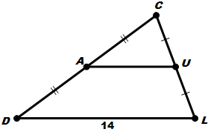**Explain why the reason the triangles are similar and find the measure of the requested side.**
9. 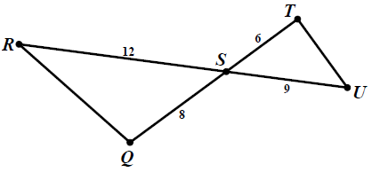 **B) *Triangle mid-segment***

**10**

*What is the measure of AU?*

*What is the measure of TU?*

1. **Using (SSS, AA, SAS) which triangles can you determine must be similar? (explain why)**

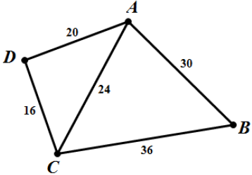

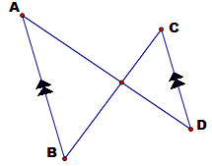**A) B) C)**

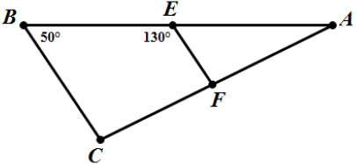

E

**Similar? YES NO**

**SSS AA SAS**

circle one

**Similar? YES NO**

**SSS AA SAS**

circle one

**Similar? YES NO**

**SSS AA SAS**

circle one

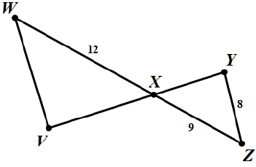

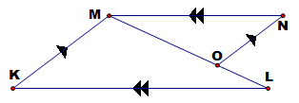**D) E)**

**Similar? YES NO**

**SSS AA SAS**

circle one

**Similar? YES NO**

**SSS AA SAS**

circle one

1. 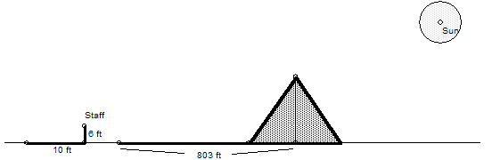**Thales was one of the first to see the power of the property of ratios and similar figures. He realized that he could use this property to measure heights and distances over immeasurable surfaces. Once, he was asked by a great Egyptian Pharaoh if he knew of a way to measure the height of the Great Pyramids. He looked at the Sun, the shadow that the**

**pyramid cast, and his 6 foot staff. By the drawing below can you figure out how he found the height of the pyramid?**

***Height of Pyramid:***

1. **Using similar devices he was able to measure ships distances off shore. This proved to be a great advantage in war at the time. How far from the shore is the ship in the diagram?**



35 f t

5 ft

3 ft

***Distance from Shore:***

***72 in.***

***21 in.***

***62 in.***



*mirror*

1. **Using a mirror you can also create similar triangles (Thanks to the properties of reflection similar triangles are created). Can you find the height of the flag pole?**

***Height of the Flag Pole:***

1. **Find the perimeter of the small rectangle based on the pictures below.**

P=36 in

15 in.

5 in.

***Perimeter of the small rectangle:***

1. **If the small can has a diameter of 1.5 ft. What is the diameter of the big trashcan? (assuming they are similar shapes)**



*2 ft*



*4 ft*

1. **If the larger spray bottle has a height of 12 in , then what is the height of the smaller bottle, assuming they are similar shapes?**

cleanercleaner

***Height of the small Spray Bottle:***

2 in .

3 in.

**17. The smaller of the two cars is a Matchbox car has a height of 1.2 inches, and the length is 2.1 inches. The height of the actual car is 64.5 inches. What is the length of the actual car? (rounded to the nearest tenth.)**

