**Sec 4.2 – Circles Inscribed Angles**

Name:

|  |  |  |
| --- | --- | --- |
| Central Angle: An angle whose vertex is the center of the circle. |  | Inscribed Angle: An angle whose vertex is on a circle and whose sides contain chords of the circle |
| *Central*  *Angle* |  | *Inscribed*  *Angle* |

**“An inscribed angle’s measure is exactly half of the arc measure that it intercepts.”**

**Find the most appropriate value for ‘x’ in each of the diagrams below. (Assume point ‘A’ is the center of the circle.)**

1. 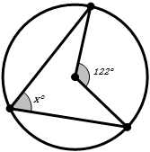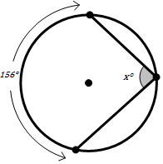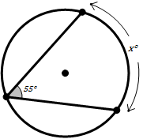 **2. 3.**

*A*

*A*

*A*

*x =*

*x =*

*x =*

**Find the most appropriate value for ‘x’ in each of the diagrams below. (Assume point ‘A’ is the center of the circle.)**

1. 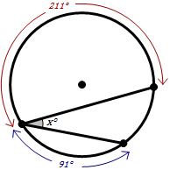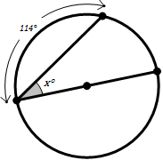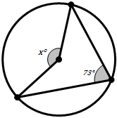  **5. 6.**

*A*

*A*

*A*

*x =*

*x =*

*x =*

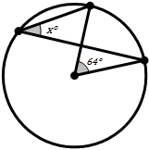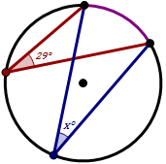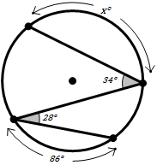**7.**  **8. 9.**

*A*

*A*

*A*

*x =*

*x =*

*x =*

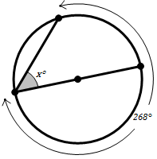

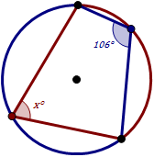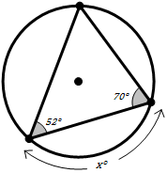**10. 11. 12.**

*A*

*A*

*A*

*x =*

*x =*

*x =*