Name: ___________________________________________ Date: ____________________________

EOC PRACTICE – Unit 5: Geometric and Algebraic Connections

1. Write the equation of the circle 

Center =

r =

1. What is the center of the circle given by the equation of x2 + y2 – 10x – 11 = 0?
   1. (5, 0)
   2. (0, 5)
   3. (-5, 0)
   4. (0, -5)

3. State whether the 3 points form a right triangle. If so, which angle is the right angle?

A(─5, 3) B(0, ─2) C(5, 3)

a. Yes,  b. Yes, 

c. Yes,  d. No

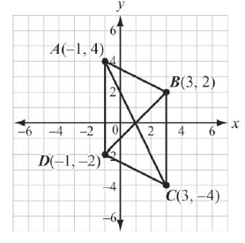4. Parallelogram ABCD has vertices as shown.   
Proving that ABCD is a parallelogram.









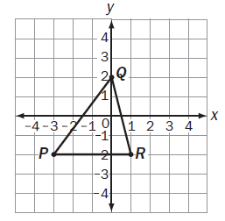

5. Look at the coordinate grid. What is the perimeter of  
 ΔPQR?

a. 

b. 14

c. 

d. 17

6. Given the points P(2, -1) and Q(-9, -6), what are the coordinates of the point on directed line segment  that partitions  in the ratio 3:2?

a. (-23/5, -4) b. (-12/5, -3) c. (5/3, 8/3) d. (-5/3, -8/3)

7. Which equation is perpendicular to?

a.  b. 

c.  d. 

8. Which is an equation of the line parallel to and passes through (-1, 3)?

a.  b. 

c.  d. 

9. Is the point (6,-5) IN, ON, or OUTSIDE of a circle with center of (3, -9) and

a radius of 5? (show distance and write a conclusion)

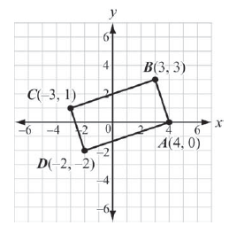

10. Prove that ABCD is a rectangle.

(show work here)

Therefore, ABCD is a rectangle because ___________________________________

and ______________________________________________________________________