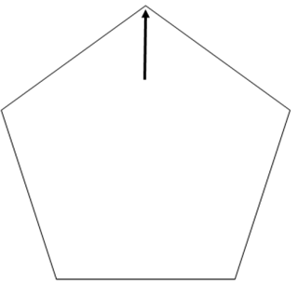
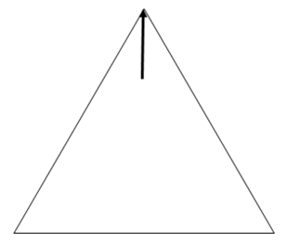

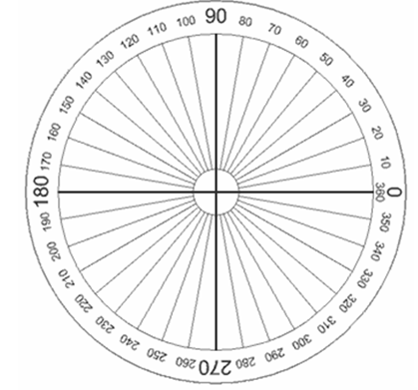

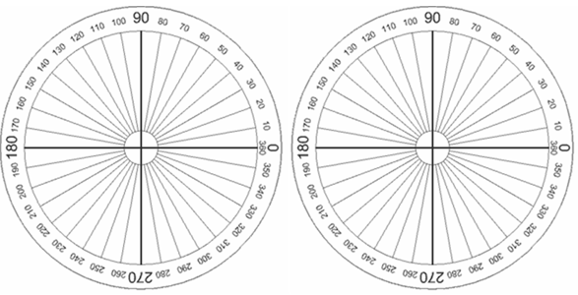

Symmetry

Name of Polygon | Degrees of Rotation that will map/carry the polygon onto itself. | Number of Reflection Lines that will map/carry the polygon onto itself.

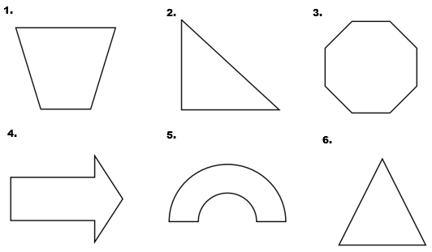
Draw all lines of symmetry on each figure.

Determine if each figure has rotational symmetry. If it does, list all degrees of rotational symmetry that are less than 360 degrees.
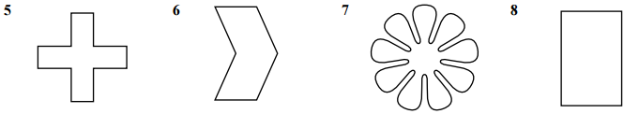

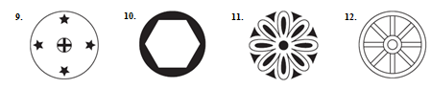

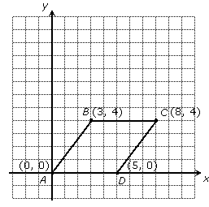
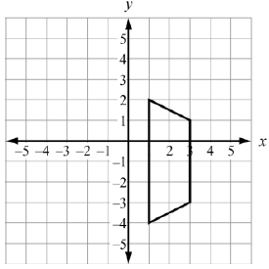
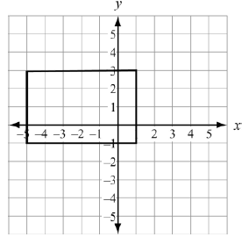
Fill in the blanks to list the transformations that map/carry each figure onto itself.

Rotate _____ degrees about ( , ) Reflect over the line __________ Reflect over the line __________
Reflect over the line __________ Reflect over the line __________
Rotate _____ degrees about ( , )

