Symmetry
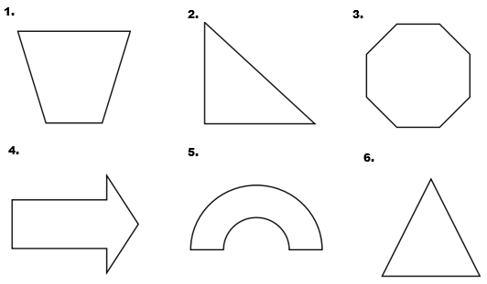
Draw all lines of symmetry on each figure.

Determine if each figure has rotational symmetry. If it does, A) list all degrees of rotational symmetry that are less than 360 degrees, and B) the order of rotational symmetry.
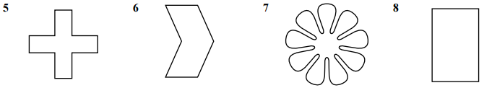

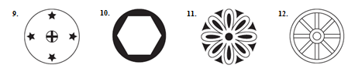

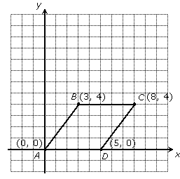
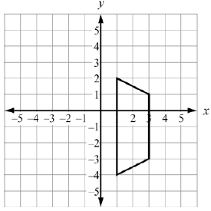
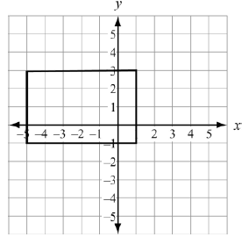
Fill in the blanks to list the transformations that map/carry each figure onto itself.

Rotate _____ degrees about ( , ) Reflect over the line __________ Reflect over the line __________
Reflect over the line __________ Reflect over the line __________
Rotate _____ degrees about ( , )

