# **QR-3 Name______________Per_____**

1. Cos β = _________ 4. Cos α= ________

β

**5**

2. Sin β = _________ 5. Sin α = ________

**4**

α

3. Tan β = ________ 6. Tan α = _______

**3**

**Solve for the missing sides using Trig Ratios (sin, cos, tan). Round answers to the nearest tenth**.

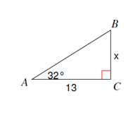

7. 8.

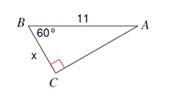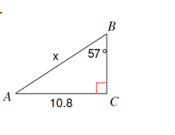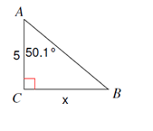

10.

9.

**Find the missing angles using inverse trig. Round answers to the nearest tenth**

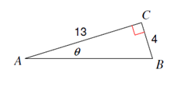

11. 12.

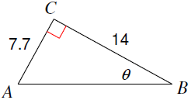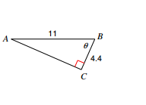

13. 14.

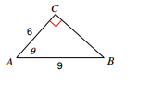

15. (a) Sin 57 ° = Cos _______° (b) cos 32.5° = sin _______°

16. Angles A and B are acute angles in a right triangle. If , then **cos B**=**__________**

17. Angles A and B are acute angles in a right triangle. If **cos A** = **,** then **sin B =__________**

**Application Problems:**

1. An 8 foot ladder is leaning against a wall so that the base is 5 feet from the base of the wall. What angle does the ladder make with the ground? Round to the nearest tenth.

Draw

Label O, A, H

Set up Trig

Calculate Answer

Write Statement

1. Joe is standing 25 feet from a building and is looking at the top with an angle of elevation of 65°. How tall is the building? Round to the nearest tenth.

Draw

Label O, A, H

Set up Trig

Calculate Answer

Write Statement

1. A kite is being flown using 100 yards of string. The kite has an angle of elevation with the ground of 55 degrees. How high above the ground is the kite?

Draw

Label O, A, H

Set up Trig

Calculate Answer

Write Statement