Honors Geometry Name:_______________________

Unit 1 Basics of Geometry and Transformations

**Assingment Guide**

**Keeping Track of your Learning**

SHOW ALL WORK, ASK QUESTIONS, CHECK THE BLOG, STAY POSITIVEMCj03970440000[1]

Required:

1-1: Geometry Notation ______

1-2: Measures of Angles ______

1-3: Collinearity and Assumptions ______

1-4:Transformation **_____**

1-5: Symmetry ______

1-6: Logic ______

Unit 1 Review ______

**Total _____**

All of the assignments are due on the day of the test

currently scheduled for Wed, Jan 16

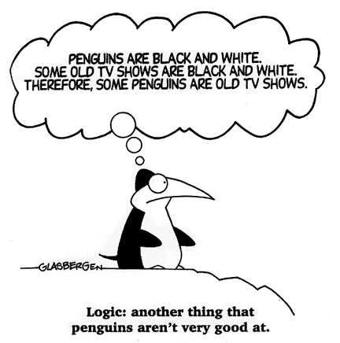

**Access the online book at:** [**http://my.hrw.com/**](http://my.hrw.com/)

**Username and Password are**

**available in class**