Name________________________________________________________________ Review Part 1

**ANGLE RELATIONSHIPS:**

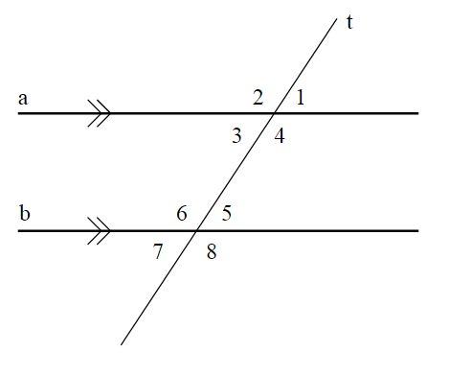1. A) Name the angle pairs and B) tell if they are congruent or supplementary.

a.  1 and  2

__________________________ _____________________

b.  1 and  3

__________________________ _____________________

c.  1 and  5

__________________________ ______________________

d.  1 and  7

__________________________ _____________________

e.  1 and  8

__________________________ _____________________

f.  3 and  6

__________________________ _____________________

g.  3 and  5

__________________________ _____________________

2. For two parallel lines and a transversal, angle 1 and angle 2 are alternate interior angles, angle 2 and 4 are corresponding angles, and angle 3 and angle 4 are alternate exterior angles. Which classification best describes the pair angle 2 and angle 3? Use the blank diagram below to organize your thoughts.

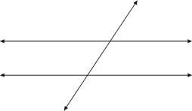

3. In the diagram shown at the below, determine whether you can prove that lines *l* and *m* are parallel. If you can, state the theorem that you would use. If you can’t, explain why.

*l m*

75°

75°

*l*

*m*

*b*

100°

100°

4. Fill in the Justifications from the bank below.

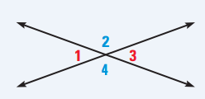**Theorem: Vertical Angles are Congruent**

**Given:**  and are a linear pair

 and are a linear pair

**Prove: **

|  |  |
| --- | --- |
| **Statement** | **Justification** |
| 1.  and are a linear pair  and are a linear pair | 1. |
| 2.  and are supplementary  and are supplementary | 2. |
| 3.  and | 3. |
| 4. | 4. |
| 5. | 5. |

* Definition of Supplementary Angles
* Given
* Subtraction property of equality
* Linear Pair Theorem
* Substitution property of equality

5. Fill in the Justifications from the bank below.

**Theorem: Alternate Interior Angles are Congruent**

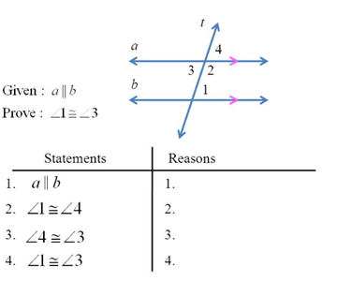

* Transitive Property
* Corresponding Angles Theorem
* Given
* Vertical Angles Theorem

**Find x to make the lines parallel. Unit 2A Review Part 2**

**6. 7.**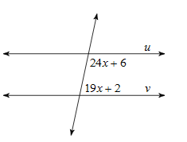

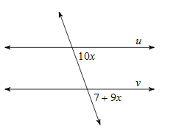

**8. Find the value of x.**

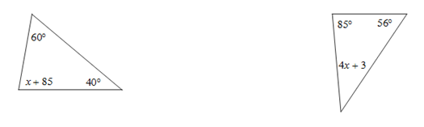

**9. Midsegments**: 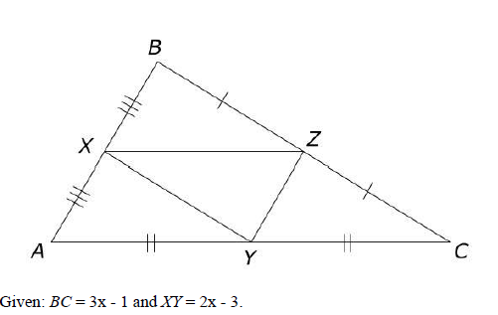 Given AB = 3x + 2 and YZ = 2x – 1, what is the **length of YZ**?

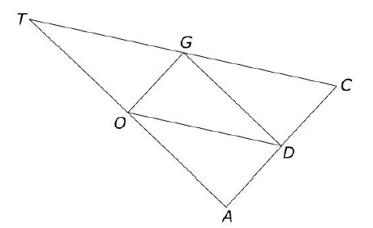10. **Midsegments**: If AC = 20, AT = 22 and CT = 24, find the **perimeter** of trianlge DOG.

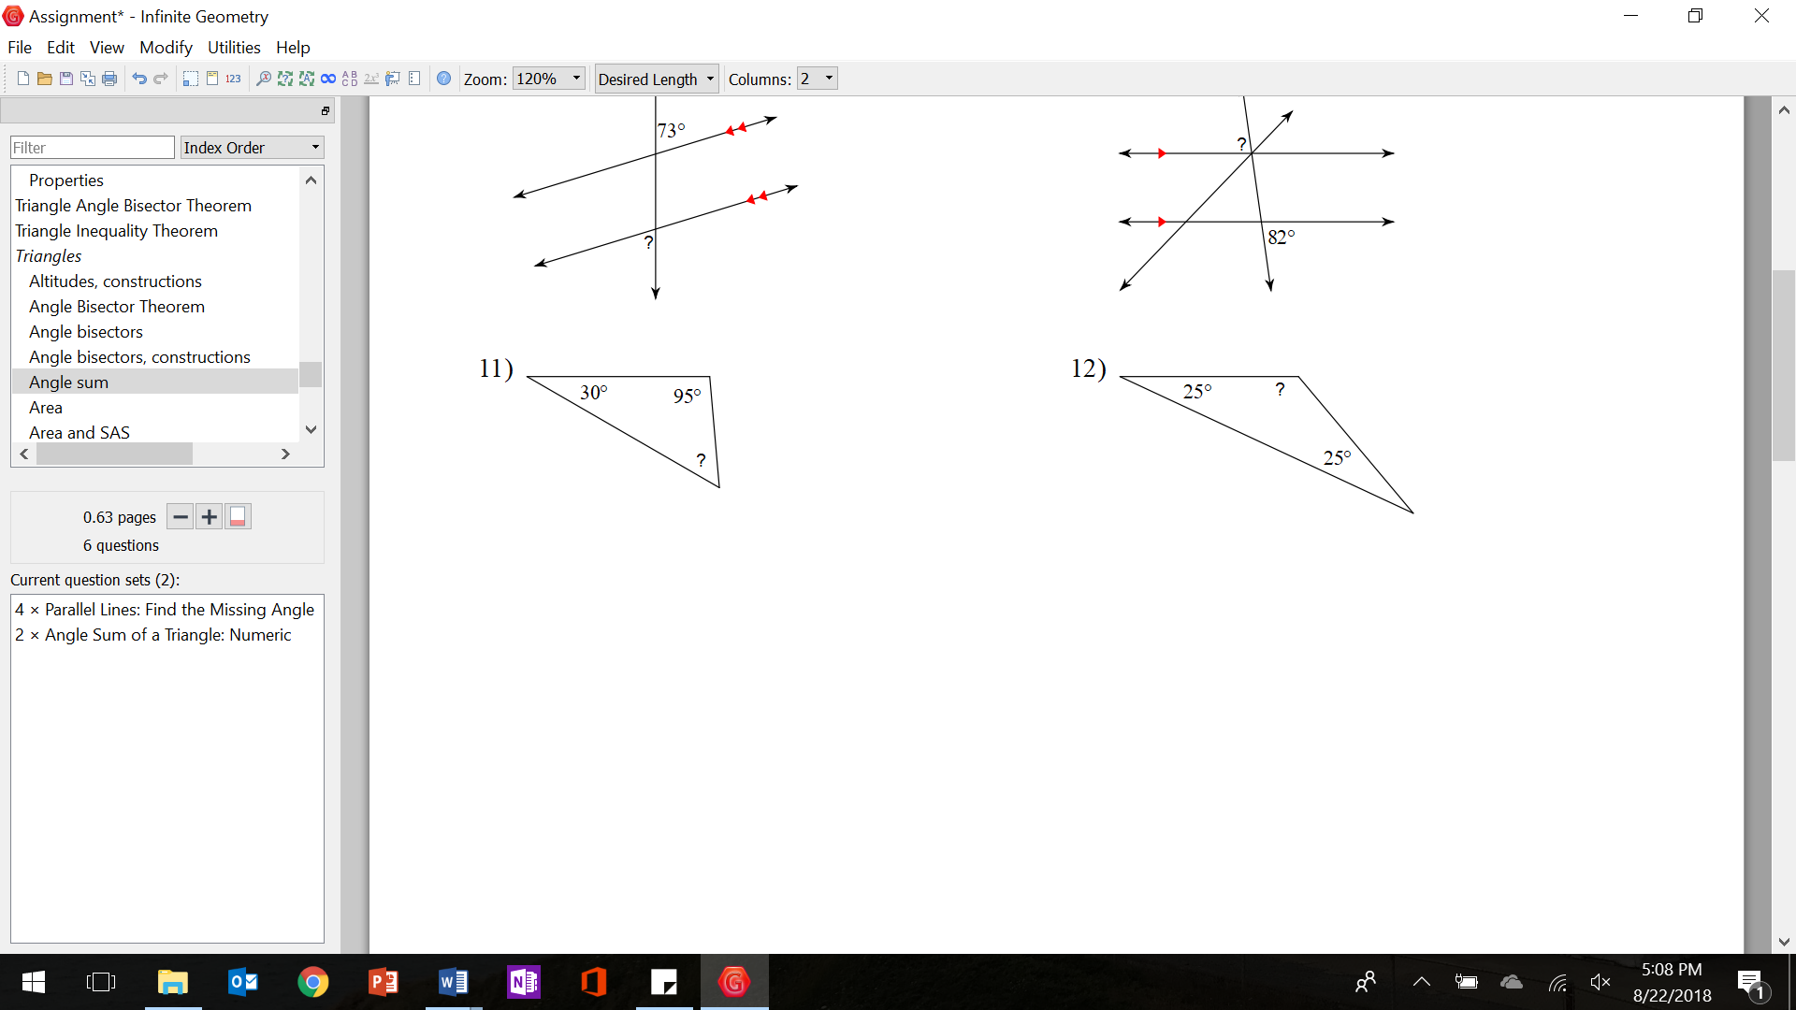

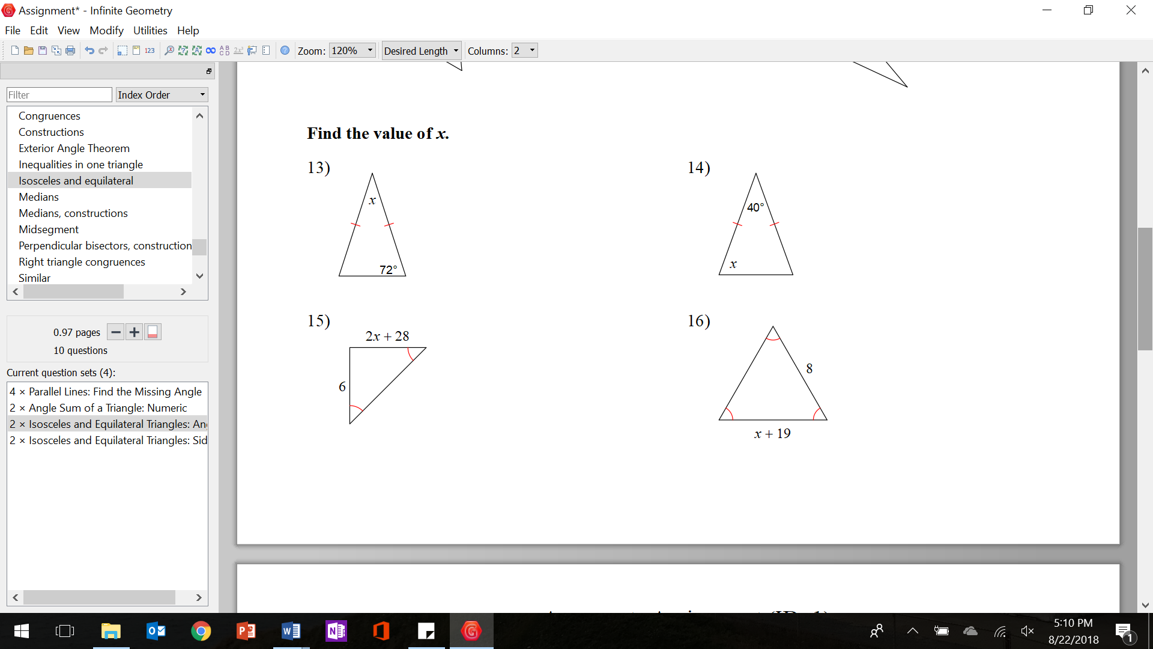

13. Use the figure to answer the question. What step should be first to draw a line perpendicualr to HJ at midpoint J?



_______________________________________________________________________________

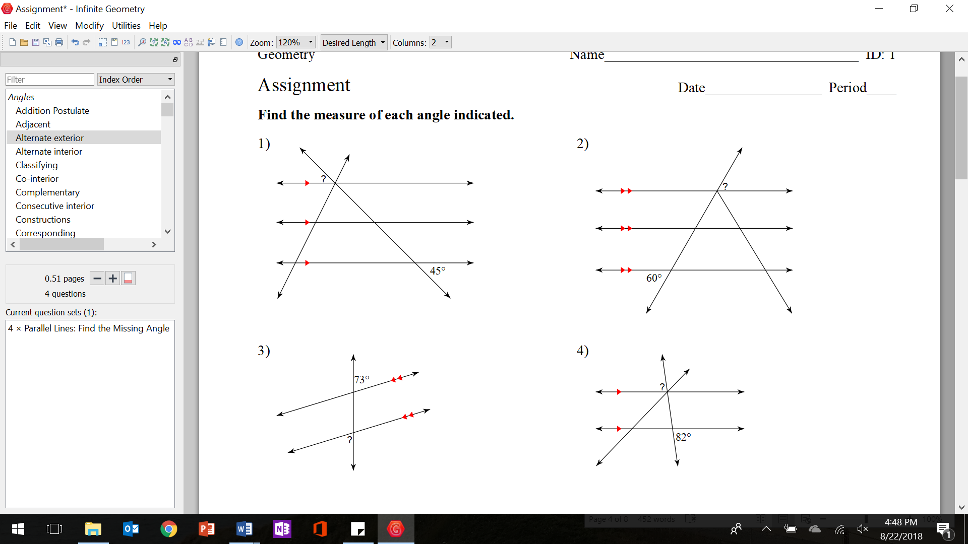

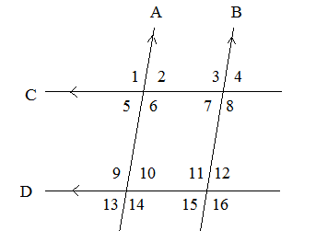***Use the figure below to answer questions 22-23.***

22. Write Congruent or Supplementary for each pair of angles?

3 and 12 _________________________ 11 and 12_______________________

4 and 15_________________________ 1 and 13____________________

23. Write true or false for each.

$∠1+∠6={180}^{o}$ $∠9-∠16={180}^{o}$

$∠2={180}^{o}-∠6$ $∠10-{180}^{o}=∠11$

___________ _____________

___________ ____________

Name________________________________________________________________ Review Sheet #3

**CONSTRUCTIONS:**

1. Copy segemnt AB and call the new one CD.

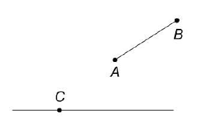

3. Bisect angle CAT.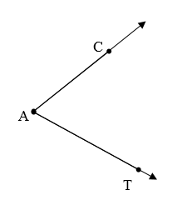 4. Construct a perpendicular bisector of the line.

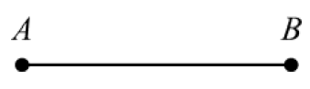

5. Construct a line parallel to line *m.*

