|  |  |
| --- | --- |
| 1. Solve for $x$. Label O, H, A. Show trig equation. Round to the nearest tenth. | 2. Find the measure of angle $x$. Label O, H, A. Show trig equation. Round your answer to the nearest degree. |
| 3. Triangle $DEF$ is a right triangle with right angle $E$, as shown. What is the area of triangle ? ?    8 in | 1. A road ascends a hill at an angle of $3°$. For every 200 feet of road, how many feet, *v*, does the road ascend? Round your answer to the nearest foot.\     3°  200 |
| 1. Given triangle $ABC$, what is to the nearest degree? | 1. In ΔABC, shown below, the measure of ∠ABC = 90º, AB = 4, AC = 5. What is the length of BD in ΔBCD, if BC = CD and ?   A  B  C  D |
| 7. According to building codes, the maximum angle of ascent for a staircase in a home is 42.5°. To get from the first floor to the second floor in a new home, a staircase will have a total vertical distance of 103.5 inches. What is the minimum horizontal distance, to the nearest inch, needed for the staircase?    103.5 in. | 8. A kite string is 100 feet long from the kite to the ground. The string makes a 41° angle with the ground. To the nearest foot, how high off the ground is the kite? |
| 9. In  ,  and , then sin T =________. | 10. In  ,  and  are complementary angles. Sin A = _______ |
| 11. Find x and y.  x=  y= | 12. Find the value of *x.*  10 ft |
| 1. Triangle ABC is similar to triangle A’B’C’. To the nearest tenth, what is the length of ? |  |

**\*\*No Calculator\*\***

1. In a right triangle, *A* and B are acute angles. If $\sin{A}=\frac{7}{24}$, what is $\cos{B}$?

1. A 12-foot ladder is leaning against a building at a 70° angle with the ground. Which can be used to find how high the ladder reaches up the side of the building?

a.  b.  c.  d. 

1. A hot air balloon is 1200 feet above the ground. The angle of depression from the basket of the hot air balloon to the base of a monument is 54°.



Which equation can be used to find the distance, *d*, in feet, from the basket of the hot air balloon to the base of the monument?

a.  b.  c.  d. 

1. Angle $J$ and angle $K$ are complementary angles in a right triangle. The value of $\tan{J}$ is $\frac{8}{6}$.

What is the value of $\sin{J}$?

a. $\frac{15}{25}$ b. $\frac{15}{20}$ c. $\frac{25}{20}$ d. $\frac{20}{25}$

1. Which is true?
2. 
3. 
4. 
5. 
6. Which equation shows a correct trigonometric ratio for angle A in the right triangle below?

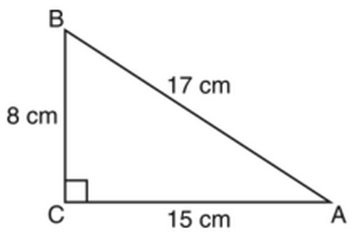

* 1.  b.  c.  d. 

**7.** Which equation could be used to find the measure of one acute angle in the right triangle shown below?

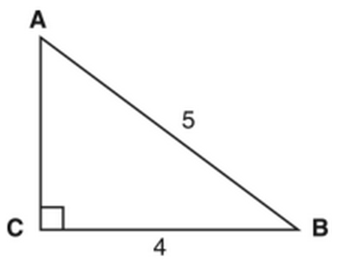

13

12

* 1.  b.  c.  d. 

1. In triangle ABC, the measure of $∠B={90}^{o}$, *AC* = 26, *AB* = 24, and *BC* =10. Which ratio represents the tangent of $∠A$?
   1.  b.  c.  d. 
2. In triangle ABC, $m∠{C=90}^{0}$. If *AB* = 5 and *AC* = 4, which statement is *not* true?
   1.  b.  c.  d. 
3. 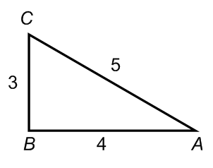Using the right triangle below, which trigonometric value is equivalent to ?
   1.  b.  c.  d. 
4. Using the right triangle below, 12. In the diagram below, . which of the following is **not** true? what ratio represents the sine of  ?

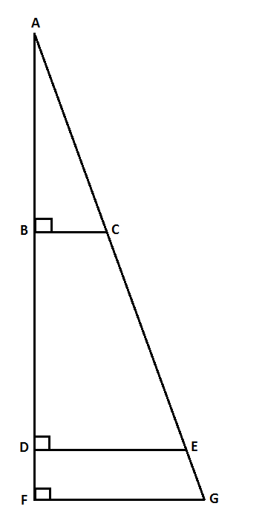a. 

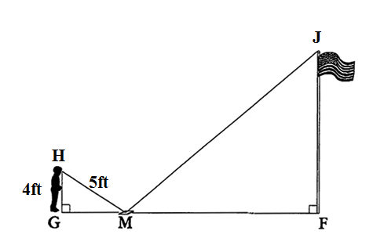b. 

c. 

d. 