# **Unit 3 Review Name______________Per_____**

1. Cos β = _________ 4. Cos α= ________

β

**17**

2. Sin β = _________ 5. Sin α = ________

**8**

α

3. Tan β = ________ 6. Tan α = _______

**15**

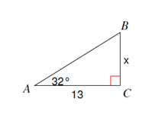**Solve for the missing sides using Trig Ratios (sin, cos, tan). Round answers to the nearest tenth**.

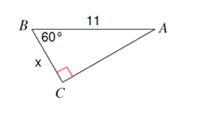7. 8.

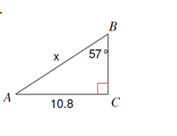

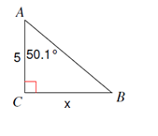

10.

9.

**Find the missing angles using inverse trig. Round answers to the nearest tenth**

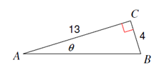

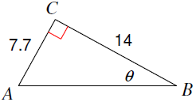11. 12.

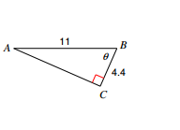

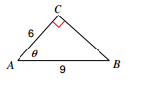 13. 14.

15. (a) Sin 57 ° = Cos _______° (b) cos 32.5° = sin _______°

16. Angles A and B are acute angles in a right triangle. If , then **cos B**=**__________**

17. Angles A and B are acute angles in a right triangle. If **cos A** = **,** then **sin B =__________**

**Application Problems:**

1. An 8 foot ladder is leaning against a wall so that the base is 5 feet from the base of the wall. What angle does the ladder make with the ground? Round to the nearest tenth.
2. Joe is standing 25 feet from a building and is looking at the top with an angle of elevation of 65°. How tall is the building? Round to the nearest tenth.
3. A kite is being flown using 100 yards of string. The kite has an angle of elevation with the ground of 55 degrees. How high above the ground is the kite?