AC2 Name:_______________________
Unit 4: Quadratics Revisited
(Yes, we are really starting with Unit 4)
Per___________
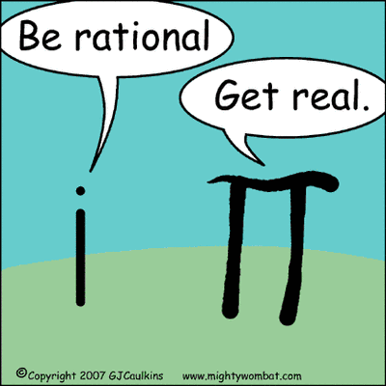
Keeping Track of your Learning
SHOW ALL WORK, ASK QUESTIONS, CHECK THE BLOG, STAY POSITIVE

Assignments
4-1: Polynomial Operations/Factoring GCF ______
4-2: Simplifying Square Roots/Factoring Trinomials ______
4-3: Imaginary Numbers/Difference of Squares ______
4-4: Simplifying Complex Numbers/Solving Quadratics ______
Quiz (Do not turn in)
4-5: Solving Quadratics with Complex Solutions ______
4-6: Review ______
Unit 4 Test
` ` Total/100 ______

All of the assignments are due on the day of the test, currently scheduled for 1/12
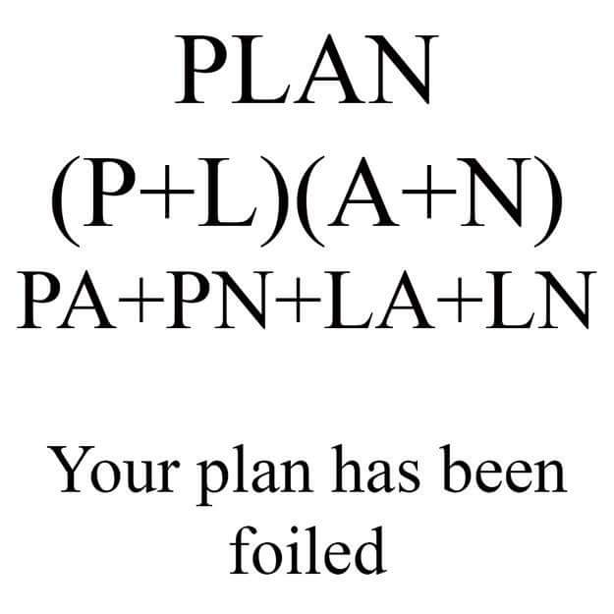
Access the online book at:
http://my.hrw.com/
Login: keith896
Password: b7r8u

