1. In the circle shown,  is the diameter and .

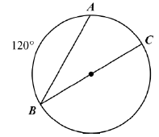

What is $m∠ABC$?

1. In the diagram below AP is tangent to circle O at point A, OB = 7, and BP = 18. What is the length of AP?

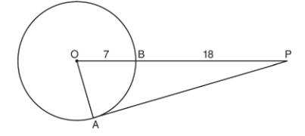

1. 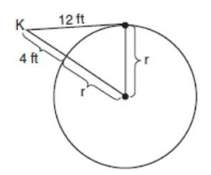Kimi wants to determine the radius of a

circular pool without getting wet.

She is located at point K, which is 4 feet

from the pool and 12 feet from the

point of tangency, as shown in the

accompanying diagram.

What is the radius of the pool?

1. 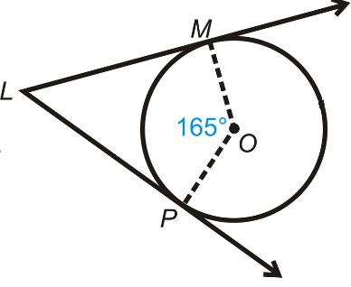In the circle below, rays  and are tangent to circle O at points M and P respectively. What is the measure of angle L?
2. 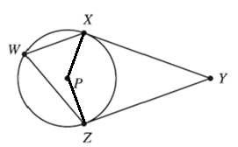Circle with center P has tangents andand chords and , as shown in the figure. The $m∠ZWX=$. What is the measure of ∠XYZ?

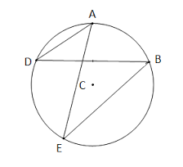

1. In the circle below,  and  .

Find the measure of .

1. 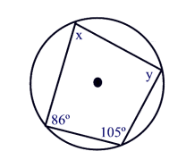Use the inscribed quadrilateral below to determine which of the following equations is **not** true.

A.  B. 

C.  D. 

1. 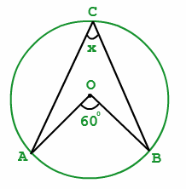Use the circle below to determine which equation is true.

A.  B.  C.  D. 

1. 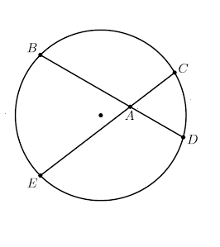In the circle below, . What is the length of *AC* ?

A. 6 B. 1.5 C. 2 D. 1.8