**Unit 4C Review: Circles and Volume**

|  |  |
| --- | --- |
| 1. Find the volume of a cone with a diameter of 10 in. and a height of 15 in.. Leave in terms of pi. | 2. What is the volume of a cylinder with a radius of 9 inches and a height of  Leave in terms of pi. |
| 3. What is the radius of a sphere with volume  ? | 1. Which is the volume of the square pyramid shown? Round to nearest tenth.     25 ft.  30 ft. |

1. The cone shown has a base with a radius of AB.

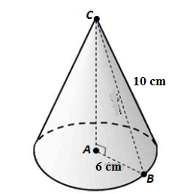

15cmm

The length of radius AB is 6 cm and the length of

**slant** **height** BC is 15 cm. What is the volume of the cone?

Leave in terms of pi.

1. A sphere is inscribed in a cube with 7. Find the volume of a cylinder with a diameter

side lengths of 7 inches. of 14 ft, and a height of 2 miles.

What is the volume of the sphere?

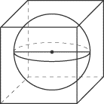

1. Cavalieri’s principle: Below is a right cylinder and an oblique cylinder using solid metal washers. The cylinders have the same height. The cylinders have the same volume because \_\_\_\_\_\_\_\_\_\_\_\_\_\_\_\_\_\_

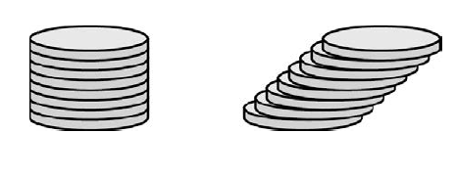 \_\_\_\_\_\_\_\_\_\_\_\_\_\_\_\_\_\_\_\_\_\_\_\_\_\_\_\_\_\_\_\_\_\_\_\_\_\_\_\_\_\_\_\_\_\_\_\_\_\_\_\_\_\_\_\_\_\_\_\_\_\_\_\_\_\_\_\_\_\_\_\_\_\_\_\_\_\_\_\_\_.

|  |  |
| --- | --- |
| 1. The figure below shows 3 tennis balls stacked tightly in a cylindrical can. The circumference of one tennis ball is   8 inches. What is the volume of the can?  Go07an_1008praC_03 | 10. What is the volume of the composite figure? Round to nearest tenth.  Image result for hemisphere on a cone volume |

1. A cylindrical tank has a radius of 8 feet. The height of the water in the tank is 20 feet. When the drain plug is pulled, the water will drain at a rate of 40 gallons per minute. The water will stop draining when the water level reaches the height of the drain. Approximately how long will it take for the water to stop draining? 

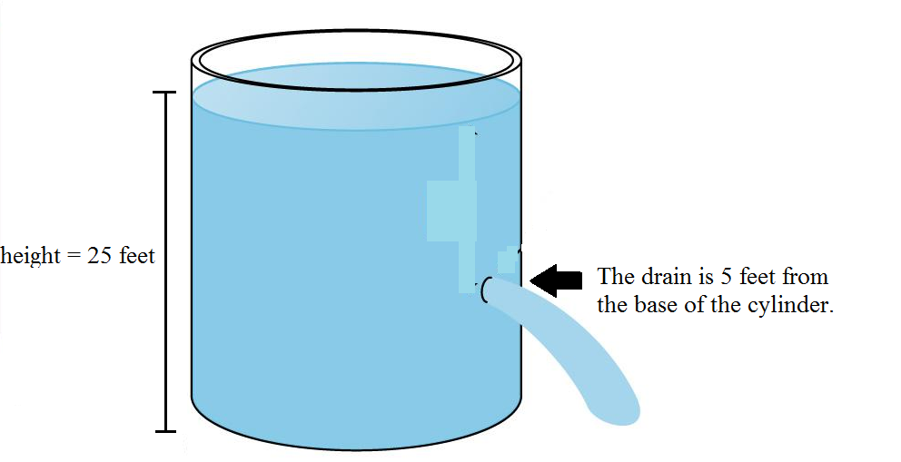

20 ft