AC2 Name:_______________________

Unit 5/6: Polynomial Functions

**Keeping Track of your Learning**

SHOW ALL WORK, ASK QUESTIONS, CHECK THE BLOG, STAY POSITIVEMCj03970440000[1]

On your own: review Exponents, Factoring (see blog Unit 5/6)

Assignments

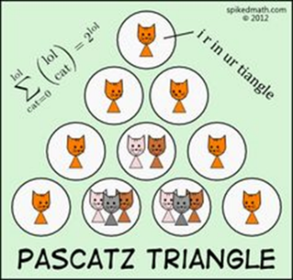 5-1: Binomial Expansion (Goes with Pg. 306-312) ______

5-2: Factoring Polynomials- Sum/Diff of Cubes and Grouping ______­

Factoring Review

5-3: Polynomial Division- Long Division and Synthetic Division ______

6-1: Solve Polynomial (Real solutions) ______

6-2: Fundamental Theorem of Algebra: (includes Imaginary solutions) ______

6-3: Graphing Polynomials ______

Zeros (Roots), y-intercept, multiplicities, and end behavior

6-4: More Graphing ______

Interval of increase/decrease, minimum/maximum

6-5: Review ______

Total/100 ______

**NOTES** and **Assignments** are due the day of the test Thursday, 2/1



**Access the online book at:**

[**http://my.hrw.com/**](http://my.hrw.com/)

**Login/Password: available in class**

Q:What do you call it when a

parrot hasn't been fed? A: Poly"no meal"