**5-REVIEW Part 1** Name: ________________________________

1. What formula is used to find each of the following?

The length of a line segment __________________________

Point in a 2:1 ratio between points ___________________________

The point in the middle of two points ________________________________

The slope of a line between two points ______________________________

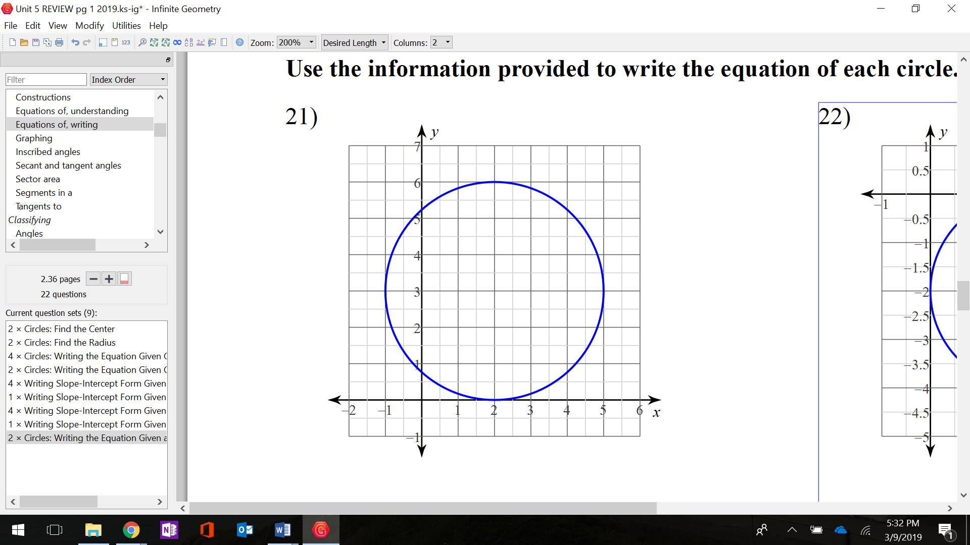

1. Identify the center and the radius of the circle.
2. Write the equation of the circle.
3. What is the equation of the circle in standard form: $﻿x^{2} + y^{2} + 18x - 24y + 189 = 0$

Equation_____________________________

Center___________

r=__________

1. Find the distance between the pair of points: $(-3, 2)$ and $(2, -1)$. (leave in radical form)
2. Find the slope between the pair of points:

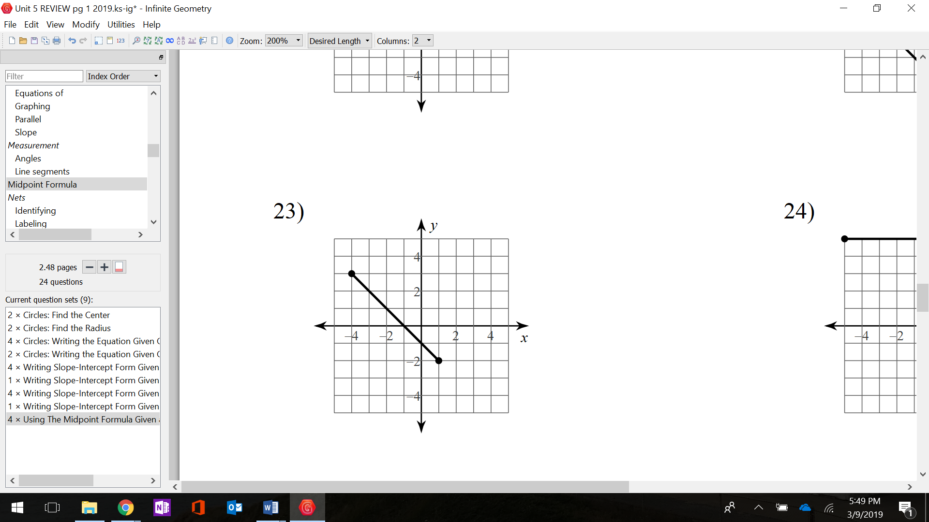 $(10, -1)$ and $(-12, -13)$.

1. Find the midpoint of the segment shown.
2. What are 2 appropriate way to prove a parallelogram is a rectangle?

_____________________________________ and _____________________________________

What are 2 ways to prove a quadrilateral is a parallelogram?

_____________________________________ and _____________________________________

What are 2 ways to prove a triangle is a Right Triangle?

_______________________________________ and _______________________________________

1. A segment has endpoints X (-4, -4) and Y (4, 2). Find the coordinates of point T that is  of the way from X to Y.
2. 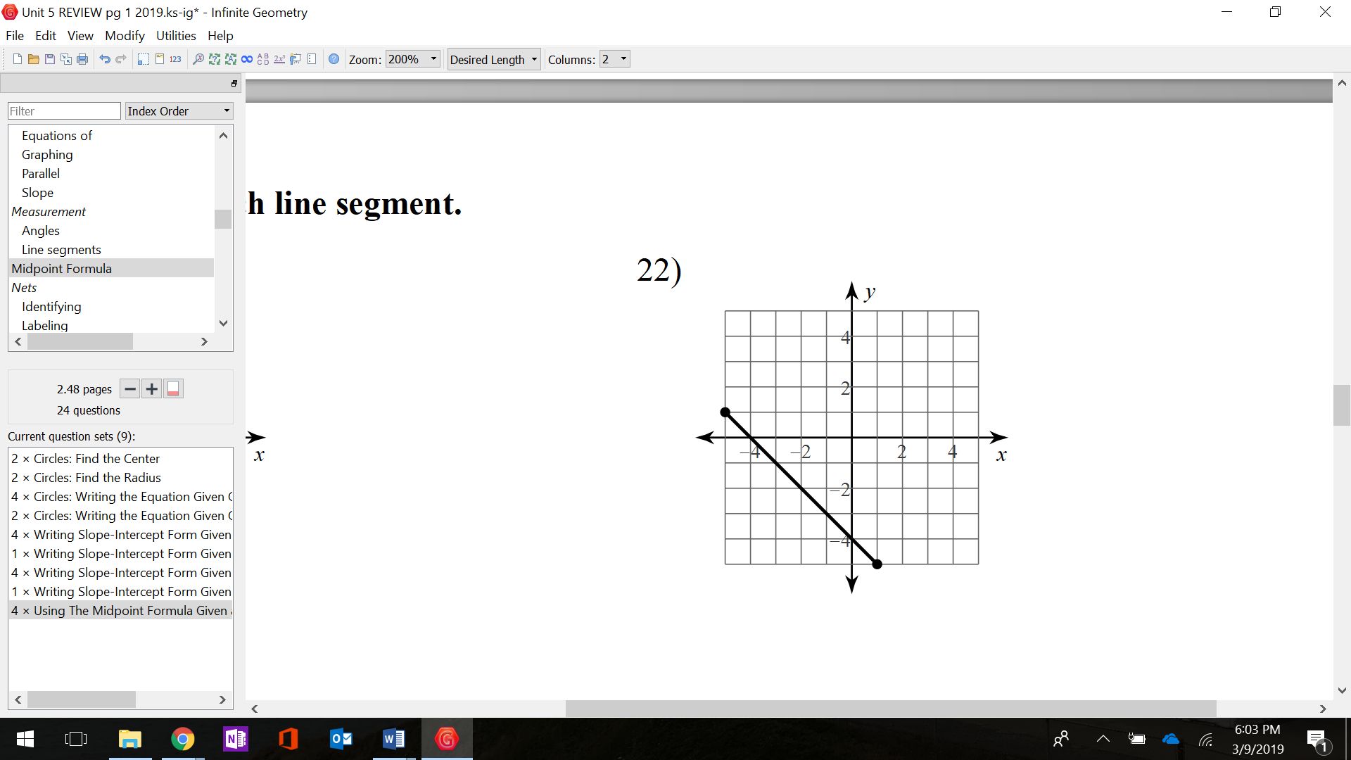 Find the coordinates that partition the line

segment in a 1:2 ratio.

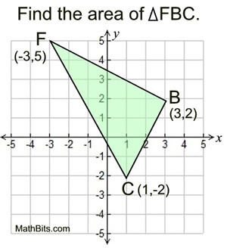

1. Find the perimeter of the triangle FBC with

vertices F(-3, 5), B(3, 2), and C(1, -2).

1. 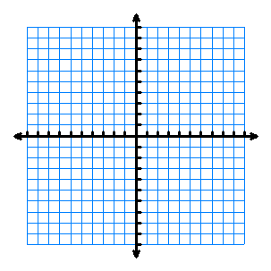 Graph the circle. State the center and radius.
$$x^{2}+y^{2}-8x-2y+6=0$$

2. Quadrilateral ABDC has vertices A(1, 5), B(5, 8), C(11, 0), and D(7, -3).
3. PROVE that the quadrilateral ABDC is a **parallelogram.**

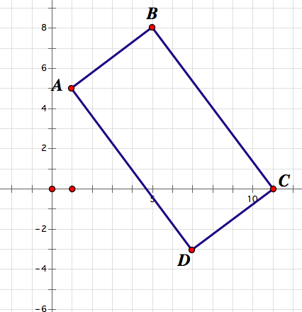

 m=

 m=

 m=

 m=

Therefore, ABDC is a parallelogram because:

1. PROVE that quadrilateral ABDC is a **rectangle**.

 m=

 m=

Therefore, ABDC is a rectangle because:

1. Circle C has a center of $(-3, 1)$ and a radius of $5.$

Does the point $(-7,-2)$ lie inside, outside or on circle C?

Show algebraic evidence to support your answer.

d=

Therefore, the point lies (inside / on / outside) the circle because: