AC2 Name:_______________________

[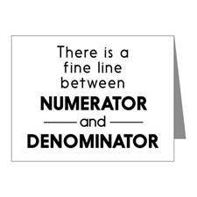](http://www.google.com/url?sa=i&rct=j&q=&esrc=s&source=images&cd=&cad=rja&uact=8&ved=0CAcQjRxqFQoTCI7C4buMmcgCFcp5PgodAPANpw&url=http://www.cafepress.com/%2Balgebra-teacher%2Bnote_cards&psig=AFQjCNGXVn-3D1rbk37B8tAYS8nP0e46cA&ust=1443507929114214)Unit 7A: Rational Operations, Solving

Per___________

**Keeping Track of your Learning**

SHOW ALL WORK, ASK QUESTIONS, CHECK THE BLOG, STAY POSITIVEMCj03970440000[1]

Assignments

7A-1: Simplify, Multiply, Divide (Goes with 13-2 pg. 409) ______

7A-2: Add and Subtract (Goes with 13-3 pg. 415) ______

7A-3: Solving and Applications (Goes with 13-5 pg. 436) ______

7A-4: Review ______

Test

` Total/100 ______

All of the assignments are due on the day of the test, currently scheduled for 10/2

[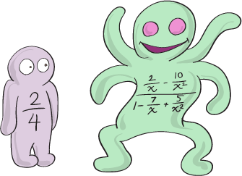](http://www.google.com/url?sa=i&rct=j&q=&esrc=s&source=images&cd=&cad=rja&uact=8&ved=0CAcQjRxqFQoTCLSWp5PemcgCFcp7kgodFzkMMA&url=http://www.shmoop.com/rational-functions/complex-rational.html&psig=AFQjCNHr-Xd3VztuCTfbPY2H_XPIu2TB1A&ust=1443529797329665)**Access the online book at:**

[**http://my.hrw.com/**](http://my.hrw.com/)

Login and Password

are posted in class