AC2 Name:_______________________

Unit 7A: Rational Operations, Solving

Per___________

**Keeping Track of your Learning**

SHOW ALL WORK, ASK QUESTIONS, CHECK THE BLOG, STAY POSITIVEMCj03970440000[1]

Assignments

7A-1: Simplify, Multiply, Divide

FlippedMath.com Algebra 2 10.2 ______

7A-2: Add and Subtract

Flipped Math.com (Algebra 2 10.3)

______

7A-3: Solving and Applications (Goes with Pg. 349) ______

7A-4 Review/Inequalities (Goes with Pg 357) ______

7A-5 Applications ______

7A-6 Graphing ______

7A-7 More Graphing

7A-8 Review ______

` Total/100 ______

[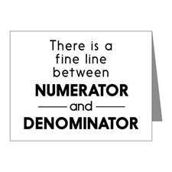](http://www.google.com/url?sa=i&rct=j&q=&esrc=s&source=images&cd=&cad=rja&uact=8&ved=0CAcQjRxqFQoTCI7C4buMmcgCFcp5PgodAPANpw&url=http://www.cafepress.com/%2Balgebra-teacher%2Bnote_cards&psig=AFQjCNGXVn-3D1rbk37B8tAYS8nP0e46cA&ust=1443507929114214)All assignments are due on the day of the test, currently scheduled for Th. 2/15

**Access the online book at:**

[**http://my.hrw.com/**](http://my.hrw.com/)

Login and Password available in class