AC2 Name:_______________________

Unit 7B: Radical Functions

**Keeping Track of your Learning**

SHOW ALL WORK, ASK QUESTIONS, CHECK THE BLOG, STAY POSITIVEMCj03970440000[1]

Assignments

7B-1:

1. Rational Exponents - ws
2. Solving Radical Equations Pg. 462 #3-21 odd ______

7B-2: More Solving Radical Equations ______

7B-3: Graphing Radical Functions (Transformations) ______

7B-4 Review ______

` Total/100 ______

All of the assignments are due the day of the test, currently scheduled for Fri 3/3

[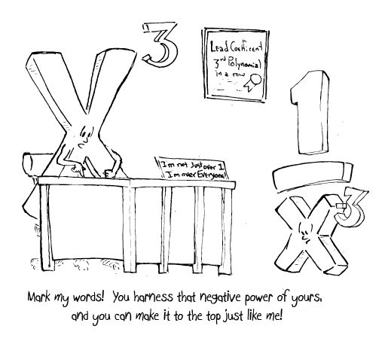](https://www.google.com/url?sa=i&rct=j&q=&esrc=s&source=images&cd=&cad=rja&uact=8&ved=0ahUKEwidx-3ow77LAhXBUyYKHfyXAsAQjRwIBw&url=https://www.pinterest.com/pin/249879479299815037/&bvm=bv.116636494,d.eWE&psig=AFQjCNFxYs-zQ73UQm7YuE4rDhgsMLJ4hg&ust=1457988270866369)

**Access online book:**

[**http://my.hrw.com/**](http://my.hrw.com/)