AC2 Name:_______________________

Unit 9 Mathematical Modeling

Per___________

**Keeping Track of your Learning**

SHOW ALL WORK, ASK QUESTIONS, CHECK THE BLOG, STAY POSITIVEMCj03970440000[1]

10.1A Graphing Rational Functions ______

9-1: Solving Equations (Review Alg 2)

10-1B Graphing Rational Functions ______

9-2: Rewriting Formulas for a given variable

Quiz Wed. 5/10 - Graphing Rational Functions ONLY

Turn in 10-1A and 10-1B BEFORE QUIZ

4-1 Transformations Packet; watch video at home ______ (Flipped Math.com; Pre-Calculus 4-1)

3.3 Piecewise Functions Packet ______

(Flipped Math Pre-Calculus 3-3)

9-3:Summation Notation and Geometric Series ______

9-4:Infinite Geometric Series ______

9-5: Review for Final ______

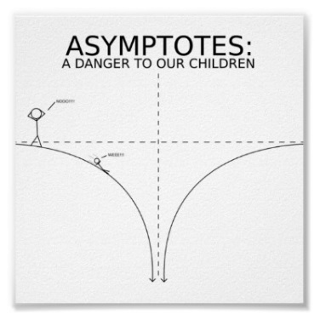 Total ______

(All Flipped Math Units are Pre-Calculus) All of the required assignments are due on the day of the

**Final: Tuesday 5/23**

**Access the online book at:**

[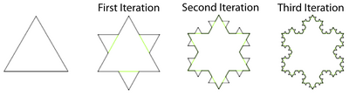](http://www.google.com/url?sa=i&rct=j&q=&esrc=s&source=images&cd=&cad=rja&uact=8&ved=0ahUKEwiht863sczJAhUDND4KHUUxASEQjRwIBw&url=http://blogs.ubc.ca/infiniteseriesmodule/units/unit-1/infinite-series/koch-snowflake-example/&psig=AFQjCNHwEPsX7dv_d79e7uM_p7vakz5QCw&ust=1449668058957167)Koch Snowflake – Geometric Series [**http://my.hrw.com/**](http://my.hrw.com/)

**Login:**

**Password:**