Name________________________________________

Volume Cylinders, Pyramids, Cones, and Spheres

Find the volume of each cylinder. Give your answers both in terms of **** and rounded to the nearest tenth.

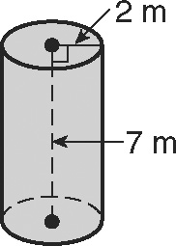1. 2. a cylinder with diameter 20 in.   
 and height 2 in.

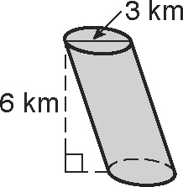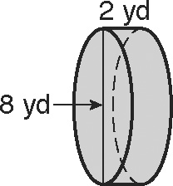

3. 4.

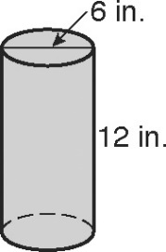5. A cylindrical juice container has the dimensions shown. About how many cups of juice does this container hold?   
(Hint: 1 cup ≈ 14.44 in3)

6. A cylinder has a radius of 6 inches and a volume of 36. What is the cylinder’s height?

7. A cylinder’s base has a circumference of 18ft. The cylinder’s height is 10 ft. What is its volume?

8. The figure shows a can of three balls. The can is just large enough so that the tennis balls

will fit inside with the lid on. The diameter of each ball is 4 in.

 a. Find the total volume of the can. b. Find the volume of empty space inside the can.

9. The cylinder below is inscribed in a cube. Find the volume of the cylinder.

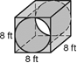

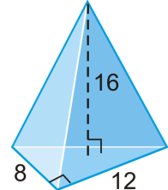Find the volume of each pyramid.

10. 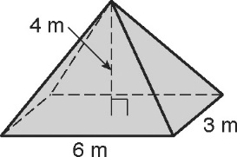 11.

the rectangular pyramid the right triangular pyramid

Find the volume of each cone. Give your answers both in terms of  and rounded to the nearest tenth.

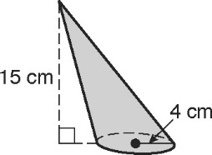 12. 13. a cone with diameter 15 yd and   
 height 10 yd

14. Find each measurement. Give your answers in terms of .

a. 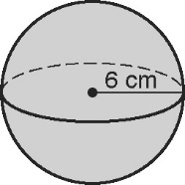 b. 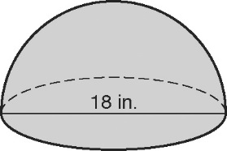

the volume of the sphere the volume of the hemisphere

15. Find the radius of a sphere with a volume of 36,000 mm3.

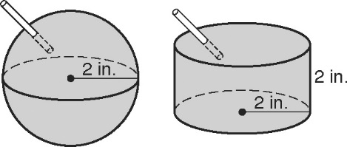16. Margot is thirsty after a 5-km run for charity. The organizers offer the containers of water shown in the   
figure. Margot wants the one with the greater volume of water. Tell which container Margot should pick.

17. Eight racquet balls fit snuggly in a box 18 inches long, 9 inches wide, and 4.5 inches deep. If each ball has a diameter of 4.5 inches, what is the volume of the space around the balls? Round to the nearest tenth.

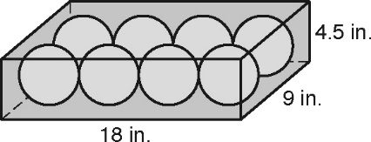

18. Find the volume of the shaded solid in the figure shown. Give your answer in terms of .

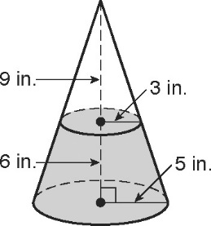

Find the area of each shaded region. Leave in terms of  .

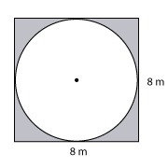19.

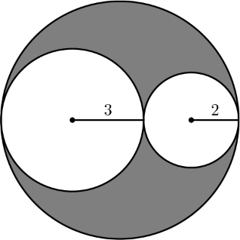20. 21.

(A) 

(B) 

(C) 

(D) 

(E) 

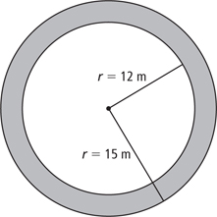

22. Find the volume of the tube below. Round to nearest tenth.

R = 10 cm, r = 4 cm, h = 20 cm

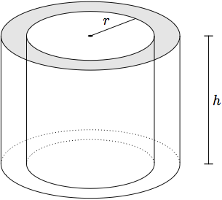

R